Bio 30 Reproduction Exams – January

January 1996

Use the following information to answer the next two questions.

The Male Reproductive System The Female Reproductive System

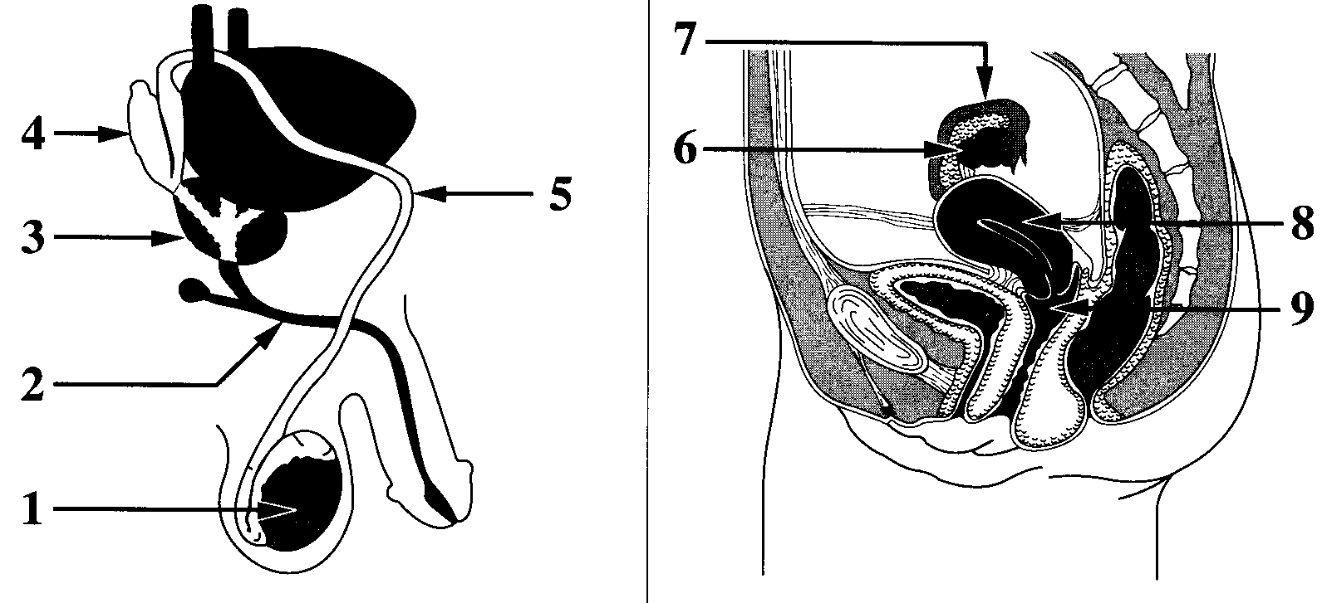

Numerical Response
1. Provide the number of the reproductive structure that is directly affected by each
technology named below.

(Record your four-digit answer in the numerical-response section of the answer sheet.)
Reproductive
structure: ______5__ ____7____ __1____ ___8_____
Technology: Vasectomy Tubal ligation Castration Use of an
intrauterine
device (IUD)

- The birth control pill prevents the maturation and release of ova. The structure that is directly affected by the birth control pill is

  - structure 6, because ova are produced by follicles in this organ
  - structure 6, because this organ will secrete excess estrogen and progesterone
  - structure 8, because implantation will not occur in this organ unless ovulation occurs
  - structure 8, because follicular development is controlled by feedback from this organ

    - The vas deferens is most similar in function to which female reproductive organ?

Ovary
      - Uterus
      - Vagina
      - Fallopian tube

Use the following information to answer the next question.
Possible Effects of Testosterone
1 Inhibits skeletal muscle development
2 Enhances skeletal muscle development
3 Inhibits development of body hair
4 Promotes development of body hair
5 Inhibits gametogenesis
6 Stimulates gametogenesis
7 Enhances growth of the larynx
8 Inhibits growth of the larynx

Numerical Response
2. Select all the correct effects of normal levels of testosterone in an adolescent male.
(Record your answer in lowest-to-highest numerical order in the numerical-response section of
the answer sheet.)

Answer: __2467_____

Use the following information to answer the next two questions.
Regulation of Reproductive Hormone Secretion

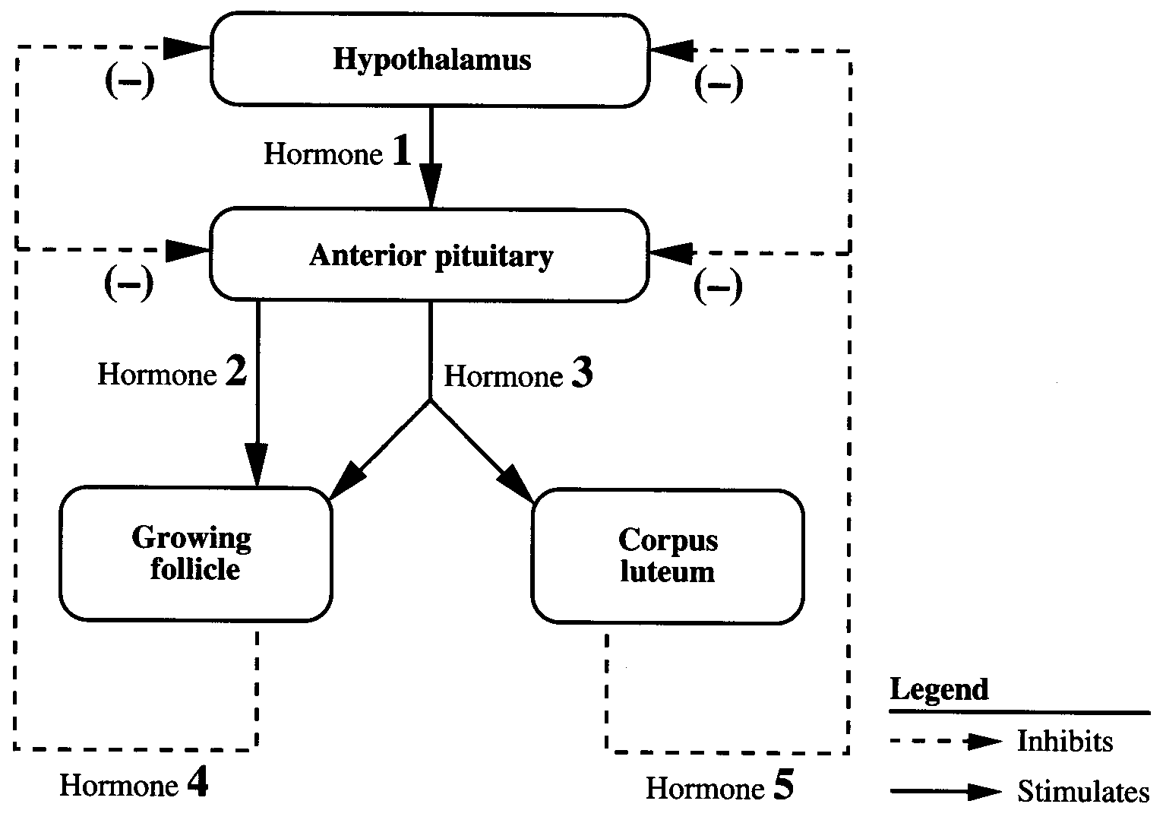

- Which row correctly identifies hormones 2, 3, 4, and 5?

Row | Hormone 2 | Hormone 3 | Hormone 4 | Hormone 5
A | FSH | LH | Estrogen | Progesterone
B | LH | FSH | Estrogen | Progesterone
C | FSH | LH | Progesterone | Estrogen
D | LH | FSH | Progesterone | Estrogen

- According to the diagram, secretion of hormone 1 is likely inhibited by
- increased levels of gonadotropins in the blood
- decreased levels of gonadotropins in the blood
- increased levels of ovarian hormones in the blood
- decreased levels of ovarian hormones in the blood

Use the following information to answer the next two questions.
Based on the principles of genetics and the analysis of cells produced by meiosis, it is
predicted that male and female humans should be produced in equal numbers. However, the
ratio of the number of males to females, known as the sex ratio, changes throughout the life
cycle. The sex ratio at conception (comparing the number of “male” zygotes to “female”
zygotes) is often as high as 1.6 to 1 in favour of males. The sex ratio at birth is 1.05 to 1 in
favour of males. In adults aged 20 to 25 years, the sex ratio is 1 to 1. After age 25, the sex
ratio shifts in favour of females.

- Which row correctly identifies one genetic factor and one environmental factor that might cause the described changes in the sex ratio?

Row | Genetic Factor | Environmental Factor
A | X-linked disorders affect  more males than females. | A male pre-embryo has a greater chance of  successful implantation than a female preembryo.
B | X-linked disorders affect  more females than males. | A male pre-embryo has a greater chance of  successful implantation than a female preembryo.
C | X-linked disorders affect  more males than females. | Accidents are the leading cause of death  among males aged 15 to 35 years.
D | X-linked disorders affect  more females than males. | Accidents are the leading cause of death  among males aged 15 to 35 years.

- Which statement provides the best explanation for the underlying cause of the sex ratio at conception?
  - Sperm that contain an X chromosome are more motile than those that contain a Y chromosome.
  - Sperm that contain a Y chromosome are more motile than those that contain an X chromosome.
  - There is a greater probability that males will produce sperm that contain an X chromosome than those that contain a Y chromosome.
  - There is a greater probability that males will produce sperm that contain a Y chromosome than those that contain an X chromosome.

- RU-486 is a drug that inhibits the action of progesterone. Hormones called prostaglandins cause the cervix to soften and dilate. Administering RU-486 and prostaglandins to a woman during pregnancy would likely cause
  - expulsion of the fetus
  - accelerated fetal development
  - a decrease in secretion of HCG by the pituitary
  - an increase in the development of the endometrium

- A home pregnancy test that is positive reveals the presence of a hormone in urine. This hormone is only present in the first trimester of pregnancy. Which hormone is detected by this home pregnancy test?
  - Progesterone
  - Oxytocin
  - Relaxin
  - HCG

- During pregnancy, menstruation is prevented by the action of
  - estrogen, initially secreted by the ovaries and later by the pituitary gland
  - estrogen, initially secreted by the corpus luteum and later by the placenta
  - progesterone, initially secreted by the ovaries and later by the pituitary gland
  - progesterone, initially secreted by the corpus luteum and later by the placenta

- A poorly developed uterine lining mainly affects the
  - lifespan of the unfertilized egg
  - implantation of the fertilized egg
  - ability of the sperm to fertilize the egg
  - development of the egg within the ovary

Use the following information to answer the next question.

Some Events that Occur During Birth

1 The baby is expelled from the uterus.
2 Secretion of progesterone decreases and the release of oxytocin increases.
3 Dilation of the cervix increases and amniotic fluid is released.
4 The placenta separates from the endometrium and is expelled.

Numerical Response
03. Provide the correct sequence of these four events that occur during birth.

(Record your four-digit answer in the numerical-response section of the answer sheet.)
Answer: __2314_____

- Infection by Chlamydia bacteria may cause tissue scarring that results in blockage of the Fallopian tubes. Without treatment, which event will still occur in an individual with this condition?
- Ovulation
- Parturition
- Fertilization
- Implantation

JANUARY 1997

Use the following information to answer the next two questions.
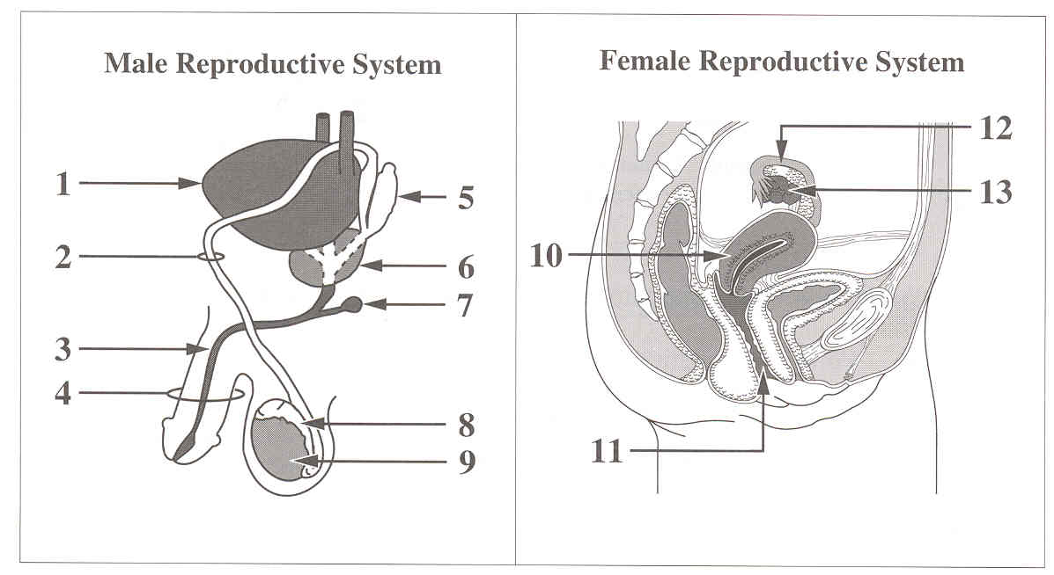

Numerical Response
02. What are the structures that are responsible for the production of the components
of semen?

(Record your answer in lowest-to-highest numerical order in the numerical-response section of
the answer sheet.)

Answer: ___5679________

- The structures that are directly affected by hormones secreted from the pituitary gland are structures
  - 6, 9, and 10
  - 9, 10, and 13
  - 8, 10, and 11
  - 8, 11, and 13

Use the following information to answer the next question.
Hormones of the Menstrual Cycle

Legend: ↑ increasing levels of
↓ decreasing levels of

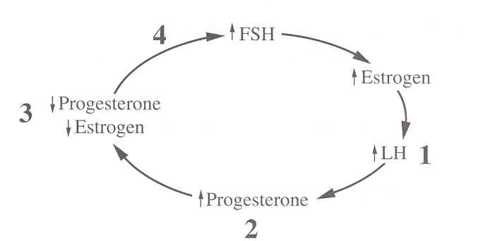

- What point on the diagram is best matched with the correct event?
  - Point 1—ovulation
  - Point 2—menstruation
  - Point 3—formation of the follicle
  - Point 4—formation of corpus luteum

Use the following information to answer the next question.

Some Terms Used to Describe Cells and Nuclear Cell Division

1 haploid
2 diploid
3 mitosis
4 meiosis

Numerical Response
03. Provide the sequence of numbers for the terms that would correctly complete the
following statement:

During human fertilization, __________ gametes produced by __________ unite to
form a __________ zygote that undergoes __________ to form a fetus.

(Record your four-digit answer in the numerical-response section of the answer sheet.)

Answer: _____1423______

Use the following information to answer the next question.
Before eggs are harvested for in vitro fertilization, hormone supplements are given to the egg
donor to ensure that mature ova will be available. Harvested eggs are fertilized and inserted
into the recipient’s uterus.

- Which hormone, if given to the egg donor, would promote the growth and development of ova?
  - LH
  - FSH
  - Estrogen
  - Progesterone

- During the process of implantation, the enzymes secreted by the
  - ovum digest the zygote membrane
  - sperm digest the zygote membrane
  - blastocyst digest a portion of the endometrium
  - blastocyst digest a portion of the corpus luteum

Use the following information to answer the next question.
At the embryonic level, there is not much difference between being male and being female.
At the University of Texas, researcher M. D. Anderson discovered a point in embryonic
development when ovaries are present in females and testes are present in males, but in each
sex, both sets of ducts (vas deferens and oviducts) coexist. In the female, the lack of
testosterone causes the vas deferens to simply wither away. In the male, a second hormone,
Müllerian inhibiting hormone (MIH), suppresses the development of female ducts. The MIH
gene is located on the X chromosome but has no function identified yet in females.

- If a substance was present in the embryo that inactivated the MIH hormone, male babies would be born with
  - female reproductive ducts and male sex chromosomes
  - male reproductive ducts and female sex chromosomes
  - male reproductive ducts and female secondary sexual characteristics
  - female reproductive ducts and female secondary sexual characteristics

Use the following information to answer the next question.
One of the major differences between the female and the male sex chromosome genotype is
that the male genotype causes the developing genital ridge, which later produces external sex
organs, to secrete testosterone, while the female genotype causes this ridge to secrete
estrogens. Injection of relatively large quantities of testosterone into pregnant animals
produces male sex organs in a fetus, even if the fetus is genotypically female.

- Which is a logical inference derived from this information?
  - Male and female embryos would be anatomically similar at one stage of their development.
  - The genital ridge would continue to secrete sex hormones during the remaining seven months of pregnancy.
  - Injection of large quantities of testosterone into a pregnant female would change the sex chromosomes of the developing embryo.
  - Injection of large quantities of estrogen into a pregnant female would enhance the development of existing sex organs in the embryo.

Use the following information to answer the next question.

Hormone Levels in Blood Plasma Before and During Pregnancy

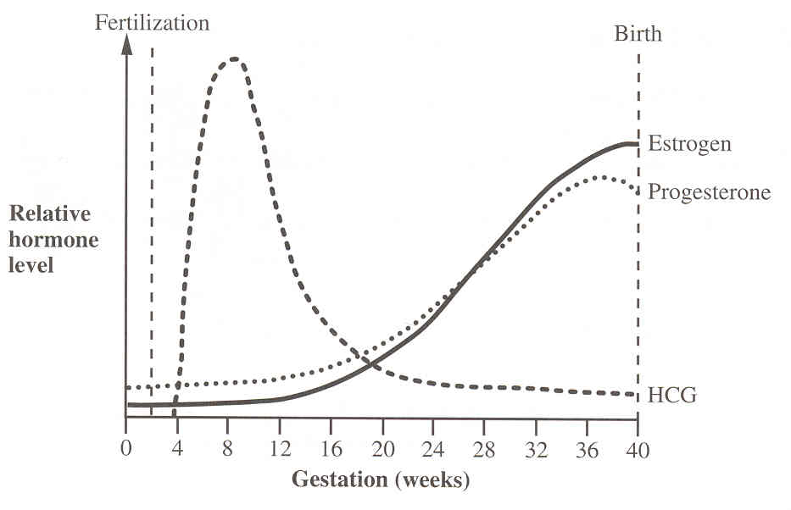

- The increasing level of HCG from the time of fertilization until week 8 serves to
  - maintain the function of the corpus luteum
  - determine the sex of the developing embryo
  - inhibit the development of the endometrium
  - direct the processes of ovulation and fertilization

- Removal of the mother’s ovaries before the seventh week of pregnancy leads to a miscarriage. After 12 weeks, removal of the ovaries usually has no effect on pregnancy. An explanation for these observations is that
  - after 12 weeks, the endometrium is easily shed
  - after 12 weeks, the placenta maintains the pregnancy
  - the follicle remains well developed for at least 12 weeks
  - implantation is not firmly established until the 12th week

Use the following information to answer the next question.
Events That Occur During Breast Feeding
(Arranged in Random Order)

1 Release of milk
2 Release of oxytocin
3 Suckling action of the baby
4 Stimulation of sensory neural pathways from the breast
to the hypothalamus-pituitary complex

Numerical Response
04. Sequence the events that occur during breast feeding.

(Record your four-digit answer in the numerical-response section of the answer sheet.)
Answer: __3___, __4___, __2___, __1___ OR 2134

Use the following information to answer the next two questions.
Female Reproductive System
Endometriosis
In some women, endometrial cells migrate
from the uterus to other places in the body,
such as surfaces of reproductive organs and
organs of the urinary system. This
misplaced endometrial tissue responds to
hormones in the blood in the same way as
the normal endometrium. This causes pain
and may severely damage the organ to which
the tissue is attached. Women who have
endometriosis do not experience these
symptoms during pregnancy. Treatment for
endometriosis includes removing excess
tissue with lasers or using hormone therapy
to mimic pregnancy.

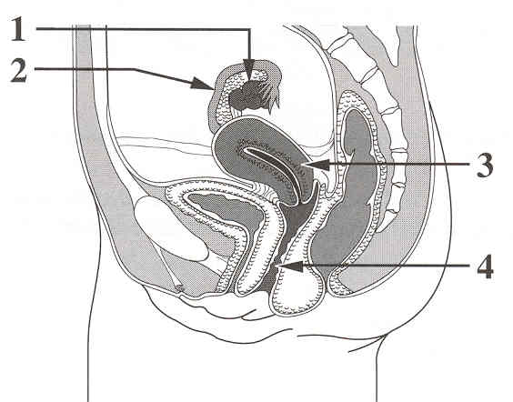

- Which hormones would be used in the hormone therapy treatment of endometriosis?
  - FSH and LH
  - LH and estrogen
  - FSH and progesterone
  - Progesterone and estrogen

- The process of fertilization would be directly affected by scarring resulting from endometriosis in structure
  - 1
  - 2
  - 3

4

- At puberty, the LH in the human male directly
    - inhibits the production of sperm
    - stimulates the production of testosterone
    - causes the growth of facial and body hair
    - stimulates the maturation of the seminiferous tubules

      - If a pregnant woman failed to produce oxytocin, what would be the result?
        - Urination would be more frequent.
        - ADH levels in the bloodstream would drop.
        - Uterine contractions would not begin for labour.
        - Oxytocin levels would increase in the bloodstream.
JANUARY 1998

Use the following information to answer the next question.
Male Reproductive System

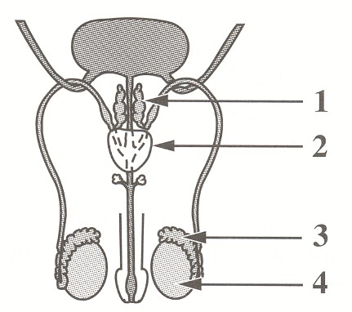

- The structure that may function both as a site for spermatogenesis and as an
endocrine gland is labeled
A. 1
B. 2
C. 3
D. 4
__________________________

Use the following information to answer the next question.
An unusual and rare form of the disease cystic fibrosis results in the absence of the vas deferens in males.
—from Henahan

- When this occurs, infertility results because of
  - decreased spermatogenesis
  - an inability to maintain an erection
  - decreased secretions of alkaline buffers
  - the failure of sperm to reach the urethra

Use the following information to answer the next two questions.

Composite Diagram of a Human Ovary

This diagram shows the sequence of events in the development of a follicle in one
reproductive cycle of a non-pregnant female.

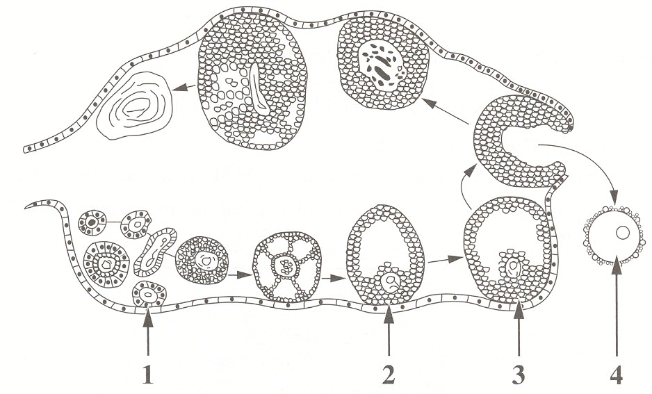

__
__
- The part of the diagram that represents the follicle just before day 14 of an average ovarian cycle is labelled
  - 1
  - 2
  - 3

4

- Which description identifies the chromosome content of cell 4?
  - n = 23
  - n = 46
  - 2n = 23
  - 2n = 46

Use the following information to answer the next question.
Microscopic examination has revealed protective layers surrounding the oocyte. The first
sperm to reach the oocyte is usually not the one to fertilize it.

- The reason this first sperm may not fertilize the oocyte is that
  - its nucleus may not be acceptable for fertilization
  - some sperm produce enzymes that fail to break down the protective layers
  - the enzymes from many sperm are needed to penetrate the protective layers
  - the protective layers secrete chemicals that destroy many sperm that contact the oocyte
__________________________

- A graph that illustrates the cyclical variation in progesterone levels in one reproductive cycle of a non-pregnant human female is
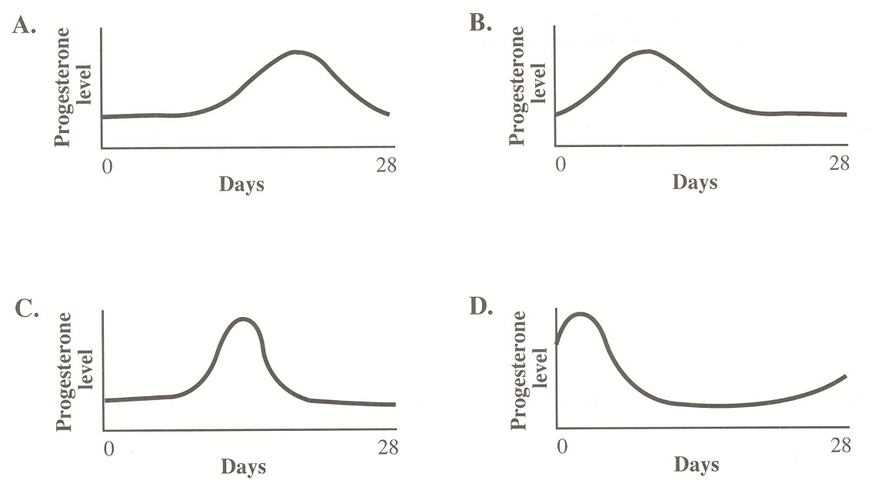

- It has been observed that some breastfeeding mothers do not ovulate until they stop breast feeding. Ovulation would not occur if
  - prolactin inhibits the release of oxytocin
  - prolactin inhibits follicular development
  - oxytocin stimulates the release of FSH and LH
  - oxytocin stimulates the release of gonadotropin-releasing hormone

Use the following information to answer the next question.
A Schematic View of the Placenta

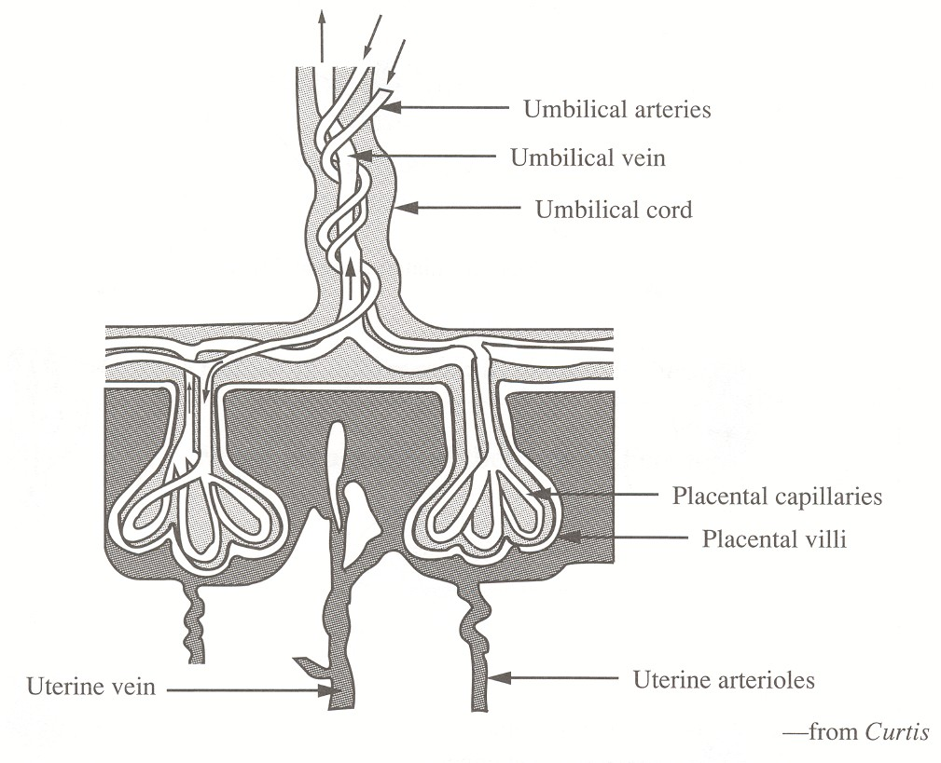

- Which of the following does not normally occur at the placenta?
  - Nutrients move from the maternal blood to the fetal blood
  - Blood cells move from the maternal blood to the fetal blood
  - Carbon dioxide moves from the fetal blood to the maternal blood
  - Metabolic wastes move from the fetal blood to the maternal blood

Use the following information to answer the next two questions.
Development of external genital structures of both sexes from the same
undifferentiated embryonic structures

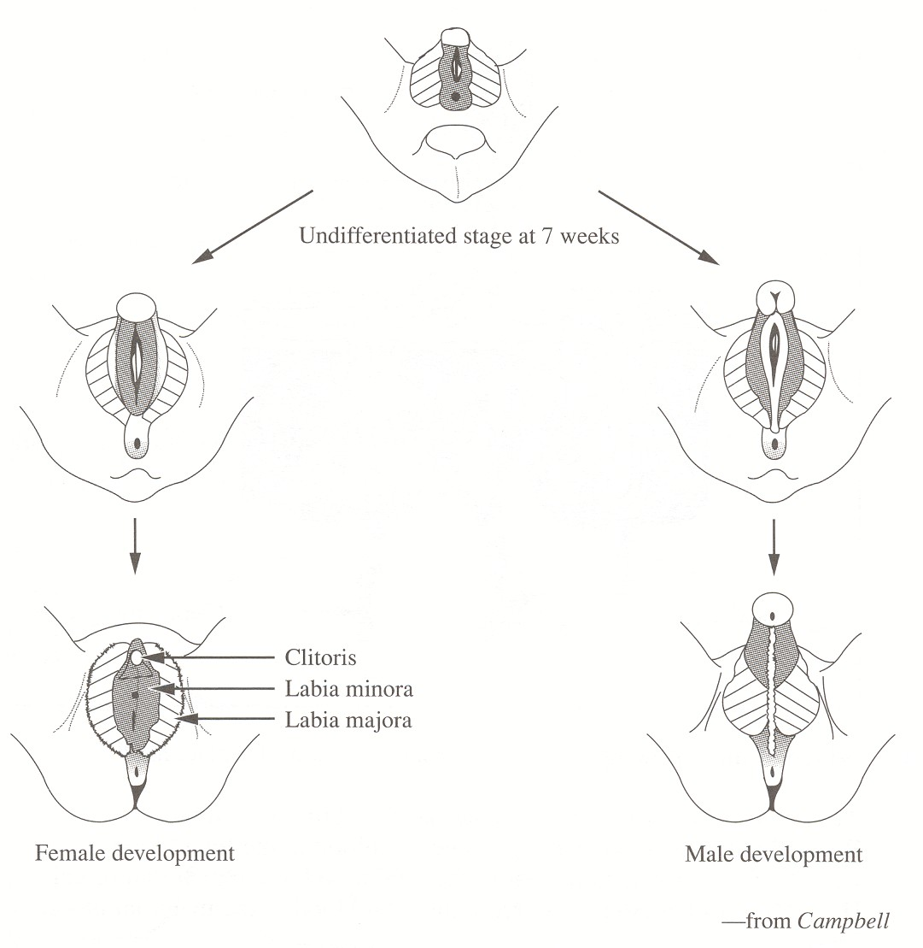

- Study the diagram. In the table below, the row that identifies two pairs of male and female external genital structures where each pair develops from the same embryonic structure is

 | Come from Same Embryonic Structure |  | Come from Same Embryonic Structure
 | Male | Female | Male | Female
A. | penis–shaft | clitoris | scrotum | vagina
B. | penis–shaft | labia majora | scrotum | labia minora
C. | penis–glans | clitoris | scrotum | labia majora
D. | penis–glans | labia majora | scrotum | labia minora

- Under normal circumstances, what initially determines whether an embryo develops into a male or a female?
  - The embryo develops testes for a male and ovaries for a female.
  - The embryo predominantly produces testosterone for a male and estrogen for a female.
  - The embryo’s genital embryonic structures develop into those of a male or those of a female.
  - The embryo develops into a male if fertilization involved a Y-carrying sperm and into a female if fertilization involved an X-carrying sperm.
________________________________

Use the following information to answer the next question.

Some Structures of the Human Female

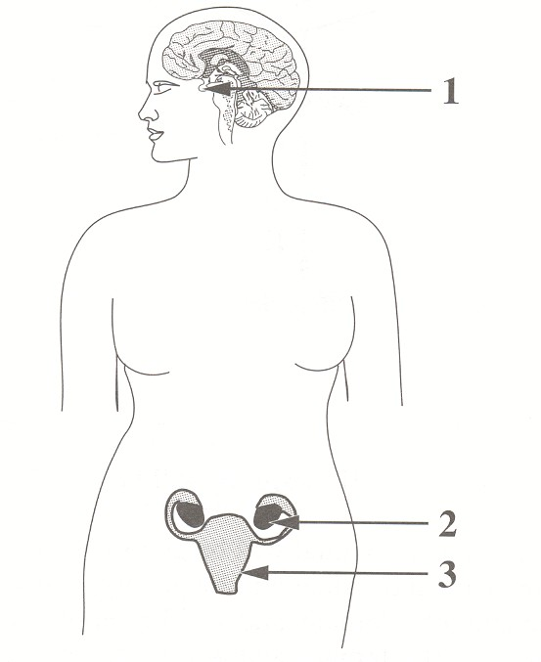

- The gland that releases oxytocin and the target organ for oxytocin are labeled, respectively,
  - 1 and 2
  - 1 and 3
  - 2 and 1
  - 2 and 3

Use the following information to answer the next question.
Nondisjunction in meiosis disrupts the chromosome number in the gametes that are produced.
Nondisjunction can occur in either the first or second division of meiosis and results in various
genetic disorders.

- One homologous pair of chromosomes in a human spermatogonium undergoes nondisjunction during the first division of meiosis. After meiosis is completed, what number of chromosomes will the four newly produced cells contain?
- All four cells will have 23 chromosomes.
- Two cells will have 22 chromosomes, and two cells will have 24 chromosomes.
- One cell will have 22 chromosomes, and three cells will have 24 chromosomes.
- One cell will have 24 chromosomes, and three cells will have 22 chromosomes.

JANUARY 1999

Use the following information to answer the next question.

The Male Reproductive System and Accessory Structures
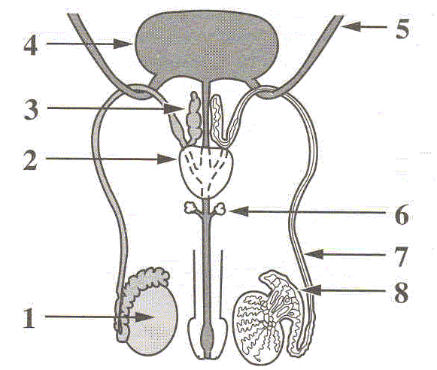

Numerical Response
01. Identify the three structures, as numbered above, that produce the fluid secretions
that make up semen.

(Record your three-digit answer in lowest-to-highest numerical order in the numerical-response
section on the answer sheet.)

Answer: __2___ __3___ __6___

- In humans, the temperature within the scrotum is usually
  - above body temperature
  - below body temperature
  - the same as body temperature
  - the same as room temperature

Use the following information to answer the next question.

Functions of the Four Main Reproductive Hormones in Human Females

1 Stimulation of egg development
2 Inhibition of ovulation and uterine contractions
3 Stimulation of the development of secondary sex characteristics
4 Stimulation of ovulation and formation of the corpus luteum

Numerical Response
02. Identify the major function, as numbered above, of each of the hormones given below.

(Record your four-digit answer in the numerical-response section on the answer sheet.)

Function: ____1______ __4________ ___3_______ ____2______
Hormone: FSH LH Estrogen Progesterone

Use the following information to answer the next question.
Reseachers have developed a birth control vaccine that would be given once a year. This
vaccine is made from a fragment of HCG attached to a protein. The vaccine causes a woman
to manufacture antibodies that bind to HCG molecules (when present) in the blood. The
antibodies prevent HCG from functioning and thereby affect the implantation of a blastocyst
(embryo).

- The vaccine affects the permanent implantation of a blastocyst by indirectly causing
  - disintegration of the endometrium
  - increased progesterone production
  - development of new follicles in the ovary
  - inhibition of the movement of cilia in the Fallopian tubes

- The onset of labour at the end of pregnancy is caused partly by a decreased level of
    - LH
    - FSH
    - estrogen
    - progesterone

Use the following information to answer the next three questions.
In vitro fertilization techniques can enable postmenopausal women (those who have gone
through menopause) to have babies. Eggs are removed from a female donor and are fertilized
in a culture dish. The early embryo is inserted into the uterus of the postmenopausal woman.
The postmenopausal woman requires hormone supplements for implantation and development
to succeed.

- To increase the chance of successful implantation of an embryo produced by in vitro fertilization, the postmenopausal woman must receive
    - FSH and LH to promote the development of the follicle
    - FSH and LH to promote the development of the endometrium
    - estrogen and progesterone to promote the development of the follicle
    - estrogen and progesterone to promote the development of the endometrium

- After in vitro fertilization, hormone supplements are administered until the fourth month of pregnancy. At this time, the hormone supplements may be discontinued because the

    - placenta produces oxytocin to inhibit uterine contraction
    - pituitary produces oxytocin to inhibit uterine contraction
    - placenta produces progesterone and estrogen to maintain the uterine lining
    - pituitary produces progesterone and estrogen to maintain the uterine lining

- During the first trimester of a pregnancy, an extraembryonic membrane secretes HCG. In a pregnancy resulting from in vitro fertilization of a postmenopausal woman, HCG would not function normally because the

- woman’s pituitary would not respond
- placenta would not produce FSH or LH
- woman would not have a corpus luteum
- placenta would not be permeable to hormones

Use the following information to answer the next two questions.
Biologists using light microscopes to study mitosis noticed that the nuclear membrane of a cell
disappeared and then re-formed during the process. They could not explain this disappearance
until they used electron microscopes to view mitotic cells. These observations revealed a large
number of vesicles (small bubble-shaped structures bounded by membranes) that appeared in
the cytoplasm during mitosis and then disappeared when mitosis was nearly complete. During
mitosis, the nuclear membrane appeared to disintegrate and form these tiny vesicles. The
vesicles disappeared when new nuclear membranes formed.

- The vesicles observed with the aid of an electron microscope appeared and disappeared, respectively, during

    - prophase and anaphase
    - prophase and telophase
    - interphase and anaphase
    - interphase and telophase

- During mitosis, the chromosomes

    - are located at the cell equator during prophase
    - are located at the cell equator during telophase
    - move toward the poles of the cell during anaphase
    - move toward the poles of the cell during metaphase

- One aspect of meiosis that is different from mitosis, is that normally by the end of meiosis

    - two diploid cells result
    - four diploid cells result
    - two haploid cells result
    - four haploid cells result

- As cells age, there is an increase in DNA damage and a decrease in DNA repair processes. The initial effect is

    - a decrease in ATP synthesis
    - an increase of cancerous cells
    - the production of altered proteins
    - the production of abnormal Mrna

- In one type of cloning, the nucleus of a cell taken from the blastula stage of an embryo is inserted into an enucleated egg cell (an egg cell with its nucleus removed). The nucleus of a cell taken from a more mature embryo would be less suitable for this type of cloning because such a nucleus would

    - be too large to fit inside an enucleated egg cell
    - be specialized because differentiation would have begun
    - lack some of the genes needed to develop into a total organism
    - undergo only meiosis, whereas cells of early embryos would undergo only mitosis

- Which of the steps of human development occurs after chorion development?
    - Fertilization
    - Implantation
    - Cleavage (division of the zygote by mitosis)
    - Organogenesis (the formation of body organs and systems)

January 2000

- The site of sperm production and the gland that produces an alkaline secretion that neutralizes the acidity of the vagina are given in row

Row | Site of Sperm  Production | Gland that Produces  an Alkaline Secretion
A | seminiferous tubules | testis
B | seminiferous tubules | prostate gland
C | seminal vesicles | testis
D | seminal vesicles | prostate gland

- Testes are responsible for the production of sperm and testosterone. Cutting and tying the vas deferens (vasectomy) blocks the passage of sperm. After a vasectomy, the hormone testosterone

  - reaches all the body tissues because it comes from exocrine tissue
  - reaches all the body tissues because it comes from endocrine tissue
  - does not reach all the body tissues because it comes from exocrine tissue
  - does not reach all the body tissues because it comes from endocrine tissue

Use the following additional information to answer the next question.

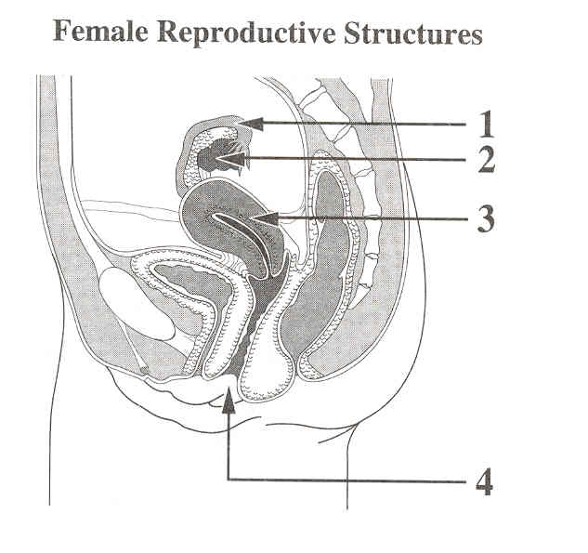

- Some contraceptives, such as condoms, prevent fertilization. Fertilization usually occurs in the structure labeled

  - 1
  - 2
  - 3
  - 4

- Another contraceptive, the birth control pill, causes negative feedback on the pituitary, which prevents the release of eggs. Typically, the hormones in the birth control pill are similar to

  - FSH and LH
  - oxytocin and prolactin
  - estrogen and progesterone
  - relaxin and gonadotropins

Use the following information to answer the next four questions.
Research on sheep might explain what stimulates pregnant mammals, including humans, to
give birth. Through research on pregnant sheep, scientists have developed the following
scheme to explain normal events as birth begins.

Influence of Fetal Hormones on the Maternal Reproductive System

Note: The placenta produces progesterone throughout the pregnancy, but activation of the
fetal hypothalamus only occurs as birth begins.
—from Discover, 1992

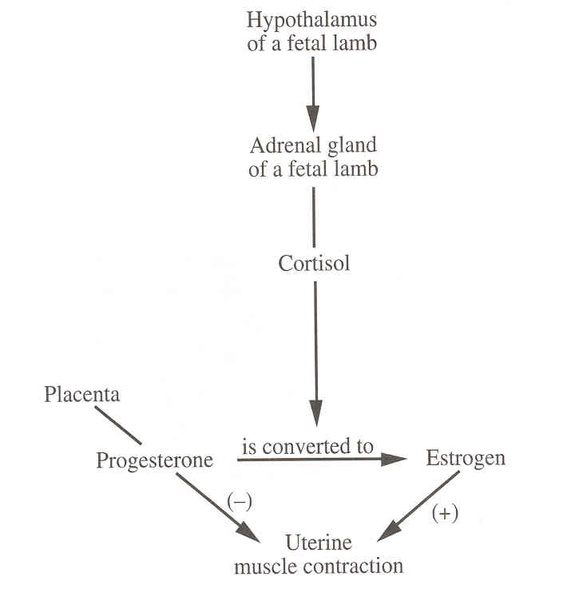

- According to this diagram, the birth of a lamb is linked to

  - increasing levels of estrogen in pregnant sheep
  - decreasing production of cortisol by the fetal lamb
  - increasing levels of progesterone in pregnant sheep
  - decreasing activity of the hypothalamus by the fetal lamb

- To maintain a pregnancy for a normal gestation period, the contraction of uterine muscles is inhibited. According to the diagram, this inhibition is brought about by

  - high levels of estrogen from the placenta
  - low levels of progesterone from the uterus
  - high levels of cortisol from the adrenal gland
  - high levels of progesterone from the placenta

- Which of the following statements concerning human reproduction is supported by the findings of this research?

  - Developments within the fetus determine when birth will begin.
  - The production of fetal cortisol delays birth until gestation is complete.
  - During early fetal development, fetal hormones do not pass into the mother.
  - High levels of progesterone in the mother’s blood are essential for birth to begin.

Use the following additional information to answer the next question.
Ingestion of a plant called skunk cabbage by pregnant sheep has been found to cause severe
birth defects and to delay birth for several weeks.

- A reasonable hypothesis is that skunk cabbage contains a chemical that

  - increases uterine sensitivity to estrogen
  - decreases placental production of progesterone
  - inhibits the fetal hypothalamus or adrenal gland
  - increases conversion of progesterone to estrogen

- Cryptorchidism is the failure of one or both of the testes to descend from the abdominal cavity into the scrotum during human fetal development. Sterility results if both testes fail to descend. In this case, the likely cause of sterility is that

  - lack of oxygen inhibits testosterone function
  - gonadotropic hormones cannot stimulate the testes
  - the testes are not connected to the external environment
  - normal sperm do not readily develop at body temperature

January 2001

Use the following information to answer the next two questions.

Mature Human Oocyte Human Sperm

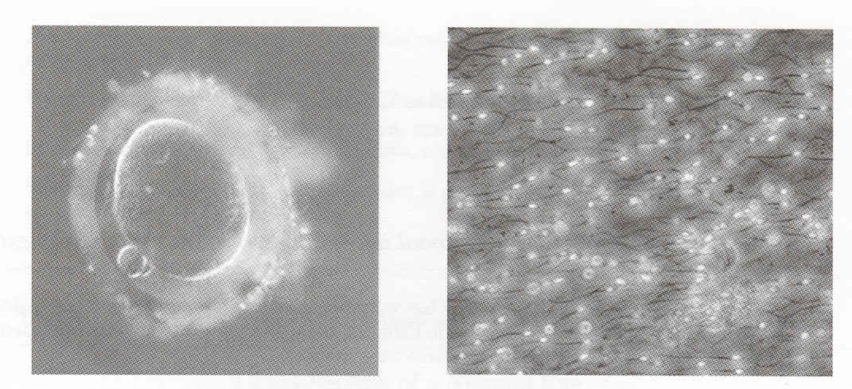

- The difference in size between the human oocyte and sperm is mostly due to the

  - difference in magnification of the two photographs
  - distance that the sperm must travel in order to reach the oocyte
  - amount of cytoplasm present in the oocyte as compared with that in the sperm
  - number of chromosomes in the nucleus of the oocyte as compared with the number in the sperm

- The nucleus of a human oocyte would normally be

  - diploid and contain 23 chromosomes
  - diploid and contain 46 chromosomes
  - haploid and contain 23 chromosomes
  - haploid and contain 46 chromosomes

- For the processes of spermatogenesis and oogenesis, respectively, the row that
identifies the hormone that stimulates the process, the location where the process
occurs, and the number of gametes produced per germ cell is

 | Spermatogenesis |  |  | Oogenesis
Row | Hormone | Location  of process | Number of  gametes  produced | Hormone | Location  of process | Number of  gametes  produced
A. | FSH | seminiferous  tubules | 4 | FSH | ovaries | 1
B. | LH | epididymis | 8 | LH | pituitary | 1
C. | testosterone | interstitial cells | 4 | estrogen | follicle | 4
D. | FSH | testes | 8 | progesterone | corpus luteum | 4

Use the following information to answer the next question.
A male is having fertility problems. His sperm are not making their way to the oocyte in time
to fertilize it. Analysis of his seminal fluid determines two insufficiencies.

- The two insufficiencies in semen that would affect sperms’ ability to travel to the oocyte are the lack of

  - FSH and testosterone
  - fructose and testosterone
  - FSH and alkaline buffers
  - fructose and alkaline buffers

Use the following information to answer the next two questions.

The picture below shows how sperm is injected into an egg. This technology may be used to
overcome infertility problems caused by sperm that are unable to penetrate an egg, or by sperm that lack a proper flagellum (tail).

Intracytoplasmic Sperm Injection (ICSI)

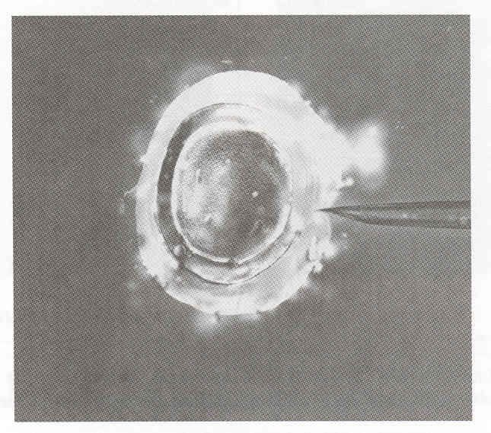

- Sperm are normally able to penetrate an egg by

  - fusing their nuclei with the nucleus of the egg
  - releasing hydrolytic enzymes from the acrosome found in the head of the sperm
  - dissolving the covering of the egg with alkaline secretions from the prostate gland
  - dissolving the covering of the egg using the hydrolytic enzymes secreted from Cowper’s gland

- If, during the ICSI process, more than one sperm head were injected into the egg’s cytoplasm,

- fraternal twins would be formed
- identical twins would be formed
- the zygote would develop into a male child since more male chromosomes would be present
- the zygote would likely not develop because more than a diploid set of chromosomes would be present

Use the following information to answer the next three questions.
Clomiphene citrate is a fertility drug used to induce ovulation in women. Clomiphene citrate,
generally taken daily from day 3 to day 7 of the menstrual cycle, decreases the naturally
circulating estrogen. The pituitary responds by increasing production of two gonadotropic
hormones that then stimulate the ovary to ripen and release an egg. Follicle development and
ovulation are usually monitored with a combination of home urine tests (on day 11 or 12) and
a follow-up ultrasound examination. About 70% of women using clomiphene citrate will
ovulate and 40% of those will become pregnant. The risk of multiple pregnancy (usually
twins) increases by 6% to 7%.

—from Bay Area Fertility and Gynecology Medical Group

- Without the negative feedback that results from increasing amounts of naturally circulating estrogen, the body responds by secreting more

  - FSH
  - HCG
  - prolactin
  - progesterone

- Following clomiphene citrate treatments, patients are advised to monitor their urine for the presence of a hormone that will signal ovulation. This hormone is

  - LH
  - FSH
  - HCG

estrogen

- The incidence of multiple births increases in women who use clomiphene citrate because high levels of

  - progesterone may stimulate the release of more than one egg
  - FSH may stimulate the fertilized egg cell to divide and separate
  - FSH may stimulate the complete development of more than one follicle
  - progesterone may stimulate the fertilized egg cell to divide and separate

- During the first three days of development, the human embryo obtains nutrients and energy from the

  - HCG
  - amniotic fluid
  - cytoplasm of the mother’s egg
  - mitochondria of the father’s sperm

Use the following information to answer the next question.

Human Embryo Six Weeks After Fertilization

Descriptions of Embryonic Structures’ Functions
A Transports embryonic blood
B Provides protection
C Is the site of exchange between embryonic and maternal blood
D Is used for nourishment in vertebrates other than mammals

- from Nilsson, 1990

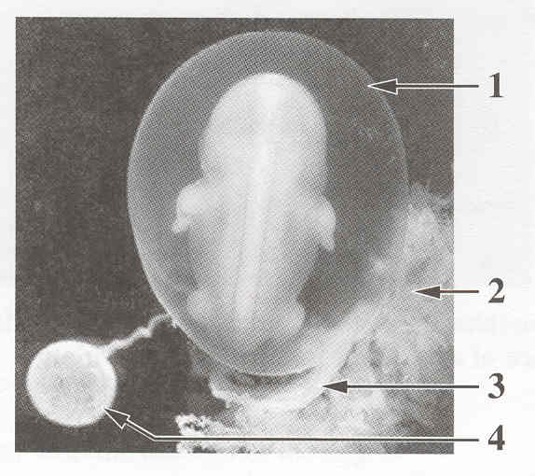

Numerical Response
02. Match each embryonic structure, as numbered above, with the letter that represents its
function, as listed above.

Structure: __3___ _1____ _2____ _4____
Function: A B C D

(Record your four-digit answer in the numerical-response section on the answer sheet.)

- The presence of a particular hormone in urine indicates that pregnancy has occurred. This hormone is secreted by the

  - ovary
  - amnion
  - chorion
  - pituitary

Use the following information to answer the next question.

Some Events in Labour

1 Uterine contractions increase in force.
2 Oxytocin travels through the bloodstream.
3 Nervous impulses are sent to the hypothalamus.
4 Oxytocin is released from the posterior pituitary

Numerical Response
03. At the onset of labour, a baby’s head pushes on the cervix. Following this,
the events given above, listed in the order in which they occur, are
__3___ , __4___ , __2___ , and __1___ .

(Record your four-digit answer in the numerical-response section on the answer sheet.)
______________________________________________

Use the following information to answer the next question.
Premature infants born at 24-weeks gestation face a wide spectrum of physiological problems.

- These problems arise because prior to the third trimester of pregnancy, fetuses

- have organs that are underdeveloped
- have not yet begun cell specialization
- depend upon amniotic fluid for oxygen
- depend upon amniotic fluid for nutrients

JANUARY 2002

Use the following information to answer the next two questions.
New research has led to advances in the development of male contraceptives. One of the most
promising contraceptive methods involves injecting androgens (testosterone or other male
hormones) into a male’s muscles. The androgens produce a negative feedback effect on the
hypothalamus and pituitary gland. In trials involving a combination of androgens, sperm
counts were reduced to zero in test subjects, but this method was effective for only three weeks.

Events in a Negative Feedback Loop Controlling Sperm Production

1 Production of sperm is inhibited
2 Hormone levels in the blood return to normal
3 Production of FSH and LH is inhibited
4 High levels of the injected androgens circulate in the blood

—from Alexander, 1999

Numerical Response
03. The order in which the events listed above would occur following the injection of
androgens into a male’s muscle is __4___, __3___, __1___, and __2___.

(Record all four digits of your answer in the numerical-response section on the answer sheet.)

Use the following additional information to answer the next question.
Researchers developing male contraceptives have found other methods of interfering with
various stages of sperm development and sperm release from the body. Some methods of
contraception currently being investigated are given below.

1 Interfering with the process of meiosis by which sperm are produced
2 Blocking the release of hormones that stimulate the release of FSH and LH
3 Using removable polyurethane plugs to block the tubes that transport sperm
4 Administering a calcium-blocking drug that interferes with the final maturation of sperm

Numerical Response
04. Match each of the methods of contraception described above with the structure given below that is targeted by that method.

Method of
Contraception: ____1______ ___4_______ ____3______ ___2_______
Structure: Seminiferous Epididymis Vas deferens Hypothalamus
tubules

(Record all four digits of your answer in the numerical-response section on the answer sheet.)
________________________________________

Use the following information to answer the next three questions.
Benign prostatic hyperplasia (BPH), an enlargement of the prostate gland, causes urination
problems such as dribbling and pain. BPH is not a precursor to prostate cancer. Prostate
cancer is linked to the absence of a protein coded for by the p27 gene. The absence of this
protein leads to uncontrolled cell growth in prostate tissue.
—from Seppa, 1998

- The movement of which of the following substances could not be affected by BPH?

- Urine
- Sperm
- Testosterone
- Seminal vesicle secretions

Use the following additional information to answer the next question.

Some Male Reproductive Structures
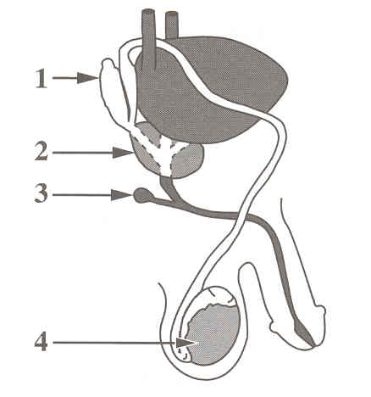

- In the diagram above, the structure most affected by the absence of the protein coded for by the p27 gene is numbered

- 1
- 2
- 3
- 4

- In normally functioning cells, the protein coded for by the p27 gene is produced continuously. The process by which the p27 gene’s code is read from the DNA and the name of the molecule formed in the process are identified in row

Row | Process | Molecule
A. | transcription | mRNA
B. | translation | mRNA
C. | transcription | tRNA
D. | translation | tRNA

Use the following information to answer the next two questions.

Human Spermatogenesis

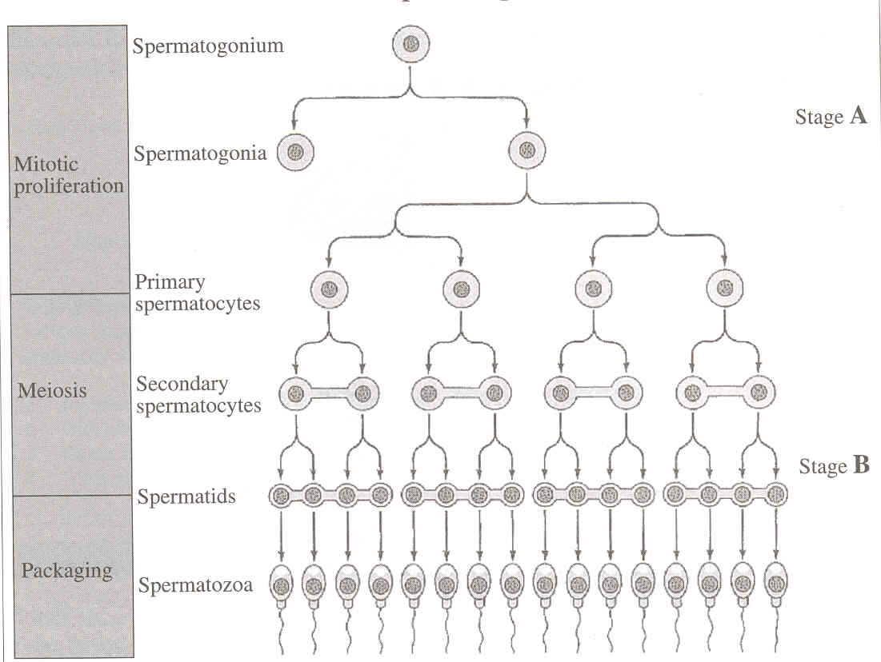

- The mitotic proliferation stage of spermatogenesis occurs in the

- epididymis
- vas deferens
- seminal vesicles
- seminiferous tubules

- The chromosome number at stage A and the chromosome number at stage B are, respectively,

- 46 and 46
- 46 and 23
- 23 and 46
- 23 and 23

Use the following information to answer the next question.
The birth of the Dionne Quintuplets on May 28, 1934, near Callander, Ontario, surprised the
world. The quintuplets had a combined weight of 6 kg, and theirs was the first known case in
which all members of a quintuplet set survived. The process by which the quintuplets were
formed is thought to be as diagrammed below.

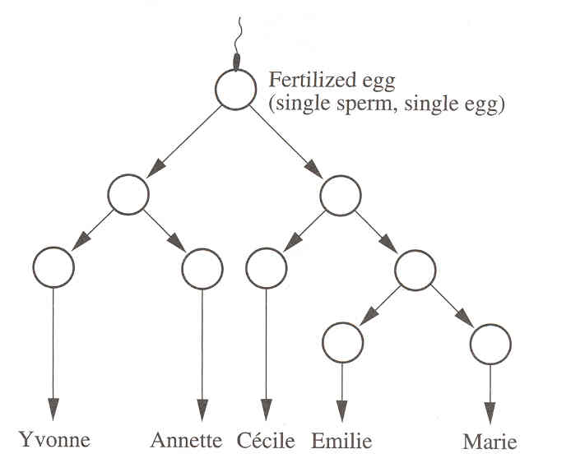

- The development of the Dionne Quintuplets was most likely the result of

- pre-embryo splitting, which resulted in fraternal quintuplets
- pre-embryo splitting, which resulted in identical quintuplets
- fertility drugs, which resulted in multiple ovulation and produced fraternal quintuplets
- fertility drugs, which resulted in multiple ovulation and produced identical quintuplets

Use the following information to answer the next three questions.

Most autosomal trisomies are lethal. The average survival age for infants with Patau
syndrome (trisomy 13) is six months. Infants with Edward syndrome (trisomy 18) survive, on
average, only two to four months. Individuals with Down syndrome (trisomy 21) can survive
into adulthood. In order to identify autosomal trisomies, chorionic villus sampling (CVS) can
be used to obtain cells that are then used to create a karyotype like the one shown below.

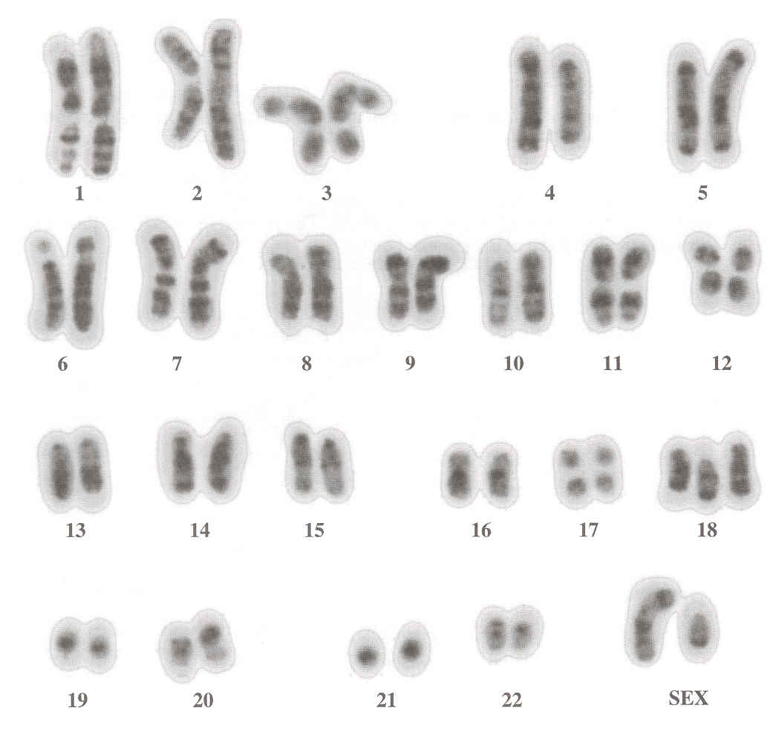

- The sex and the condition of the individual whose karyotype is shown above are given in row

Row | Sex | Condition
A. | female | Patau syndrome
B. | female | Down syndrome
C. | male | Edward syndrome
D. | male | normal

- The villus region sampled using CVS develops from the

- amnion
- chorion
- ectoderm
- endoderm

Use the following additional information to answer the next question.
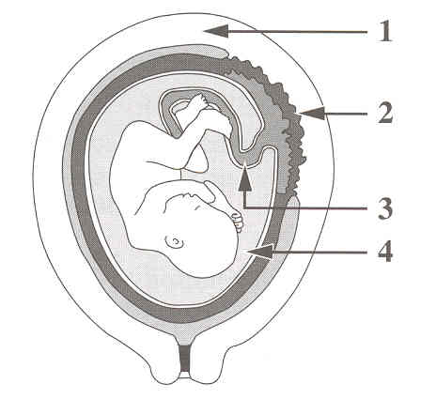

- Progesterone and HCG, which are used to maintain the developing fetus, are both produced in the structure numbered

- 1
- 2
- 3
- 4

