Bio 30 Nervous System and Homeostasis January Diploma Exam Questions

January 1996

- Which gland produces a hormone that directly increases blood supply to skeletal muscles and increases the rate of contraction of heart muscle?
  - Pancreas
  - Adrenal gland
  - Thyroid gland
  - Pituitary gland

- Which sequence illustrates a mechanism used by the body to control the blood glucose level?
  - Blood glucose increases → release of glucagon increases → conversion of glycogen into glucose decreases → blood glucose decreases
  - Blood glucose decreases → release of glucagon decreases → conversion of glycogen into glucose decreases → blood glucose increases
  - Blood glucose increases → release of insulin increases → conversion of glucose into glycogen increases → blood glucose decreases
  - Blood glucose decreases → release of insulin decreases → conversion of glucose into glycogen increases → blood glucose increases

Use the following information to answer the next question.
Diabetes insipidus is a disorder of the posterior lobe of the pituitary gland or hypothalamus
resulting in decreased secretion of a specific hormone. This disorder is characterized by the
excretion of large volumes of urine and subsequent dehydration and thirst.
A person with diabetes insipidus can be treated by inhaling a spray containing the hormone
that is deficient. The spray is inhaled several times a day.

- The inhaled spray would likely contain
  - insulin
  - glucagon
  - aldosterone
  - antidiuretic hormone
1
Use the following information to answer the next two questions.
When the Chernobyl nuclear reactor in Ukraine melted down, clouds of radioactive material,
including iodine, were released into the atmosphere. Iodine is actively absorbed by a certain
gland in the body. Scientists were worried that the radioactive iodine would cause tumours in
this gland. In an attempt to avoid this problem, people who lived near the reactor were given
large doses of non-radioactive iodine.

- How would the ingestion of large doses of non-radioactive iodine reduce a person’s chances of getting a tumor in a particular gland?

  - The pituitary would become saturated with non-radioactive iodine and this would limit the absorption of radioactive iodine.
  - The thyroid would become saturated with non-radioactive iodine and this would limit the absorption of radioactive iodine.
  - Increased levels of iodine would stimulate hormonal production by the pituitary and limit tumor formation.
  - Increased levels of iodine would stimulate hormonal production by the thyroid and limit tumor formation.

- If a tumor caused increased secretion of thyroxine, which symptoms would likely be experienced by an affected person?
  - Increased body temperature and increased metabolic rate
  - Increased body temperature and decreased metabolic rate
  - Decreased body temperature and increased metabolic rate
  - Decreased body temperature and decreased metabolic rate

- The pituitary hormone ACTH regulates the production of aldosterone by the cortex of the adrenal glands. A severe drop in ACTH levels would likely result in
  - decreased sodium ion retention and increased water loss because aldosterone levels would rise
  - decreased sodium ion retention and increased water loss because aldosterone levels would drop
  - increased sodium ion retention and increased water retention because aldosterone levels would rise
  - increased sodium ion retention and increased water retention because aldosterone levels would drop

- Sensory and motor neurons of the peripheral nervous system transmit impulses between muscles and the
  - parasympathetic nervous system
  - sympathetic nervous system
  - central nervous system
  - endocrine system

- Which sequence correctly shows the path of sound transmission in the ear?
  - Tympanic membrane → eustachian tube → semicircular canals → cochlea
  - Tympanic membrane → semicircular canals → eustachian tube → cochlea
  - Auditory canal → ossicles → tympanic membrane → organ of Corti
  - Auditory canal → tympanic membrane → ossicles → organ of Corti

- A person with a vitamin A deficiency may have night blindness. The glare from the headlights of an approaching car will temporarily reduce that person’s visual capacity. The primary structures associated with this change are the
  - cornea and lens
  - retina and rod cells
  - fovea and blind spot
  - choroid and cone cells

- A person who occasionally experienced paralysis was examined and found to have very low levels of potassium in the blood and other tissues. The paralysis likely resulted because of the inability of

  - capillaries to provide adequate blood flow
  - axon terminals to break down acetylcholine
  - neurons to repolarize during the refractory period
  - neurons to remove acetylcholine from the synapse

Use the following information to answer the next three questions.

More than 4 000 Gulf War veterans complain of illness (Gulf War Syndrome). The veterans’
symptoms include joint pain, shortness of breath, attention and memory problems, and chronic
fatigue. During the war, most of the veterans took anti-nerve-gas pills. These pills contain
pyridostigmine bromide, a drug that inhibits cholinesterase. Pyridostigmine bromide is also used to treat patients with myasthenia gravis, an inherited disorder characterized by weakness of skeletal muscles.

- The role of cholinesterase in neural transmission is to
  - increase the rate of nerve impulse transmission
  - promote the breakdown of a neurotransmitter
  - increase the sensitivity of neural membranes
  - promote the synthesis of a neurotransmitter

- Considering that the symptoms of Gulf War Syndrome include attention and memory problems, it is likely that pyridostigmine bromide has an effect on the
  - cerebrum
  - cerebellum
  - hypothalamus
  - medulla oblongata

- In myasthenia gravis, a malfunction of neuromuscular synapses occurs. The information presented above indicates that the muscular weakness associated with this disorder occurs because
  - axons secrete excess acetylcholine
  - axons secrete insufficient acetylcholine
  - of increased permeability of membranes to sodium ions
  - of decreased permeability of membranes to potassium ions

Use the following information to answer the next question.
Scientists had long assumed that the brain could not produce new cells. However, two
researchers at the University of Calgary have successfully produced new brain tissue by using
an unspecialized brain cell known as a stem cell. This stem cell acts as a “mother” cell to
produce healthy brain tissue, in vitro.

- Before this research, the assumption that brain cells could not regenerate was based upon which characteristic of axons?
  - Axons of the peripheral nervous system are surrounded by a neurilemma.
  - Axons of the central nervous system are surrounded by a neurilemma.
  - Axons of the peripheral nervous system lack a neurilemma.
  - Axons of the central nervous system lack a neurilemma.

Use the following information to answer the next question.
Parkinson’s disease destroys certain neurons in the brain. One treatment for Parkinson’s
disease is to transplant fetal brain tissue into a patient to replace neurons destroyed by the
disease.

- Which is a likely reason why fetal brain tissue, rather than brain tissue from an adult donor, is used to treat Parkinson’s disease?
  - Fetal neurons can undergo meiosis but adult neurons cannot.
  - Fetal neurons can undergo mitosis but adult neurons cannot.
  - Adult neurons are more complex than fetal neurons.
  - Adult neurons are much larger than fetal neurons.

January 1997 – Used this #6 in NS Exam!

Use the following information to answer the next question.
Certain compounds known as opiates (opium, morphine, and codeine) are addictive drugs.
Scientists have found that opiates work by binding to specific sites in the brain that interpret
perceptions of pleasure and pain.

- A likely explanation of how receptors in the human brain are stimulated by opiates is that opiates

  - bind to neurotransmitters
  - act in the same way as cholinesterase
  - increase the strength of action potentials
  - have molecular shapes similar to a neurotransmitter

Use the following information to answer the next three questions.
Measuring the Membrane Potential of a Spinal Neuron
A microelectrode can be inserted into the axon of a neuron in order to measure the
differences in charge between the outside and inside of the cell. A specialized, sensitive
voltmeter is used to measure this difference. Electrode 1 is placed on the outside of the cell
membrane and Electrode 2 is placed on the inside of the cell membrane.

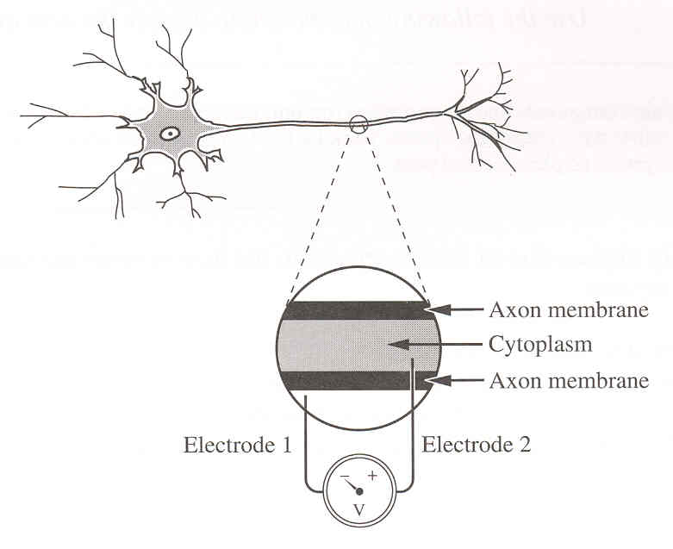

- The neuron in an experiment was taken from a spinal cord. The propagation of an action potential in the neuron was slower than the 24 m/s that is typical with sensory neurons. Why?
  - Myelination was absent in this spinal neuron.
  - Axon length is much longer in sensory neurons.
  - The Nodes of Ranvier were absent in sensory neurons.
  - The neurotransmitters were blocked in this spinal neuron.

    - The voltmeter showed a negative reading and the sodium ion concentration
remained constant outside the axon. How could this be explained?
- The threshold for the neuron was not reached.
- The sodium pump had exhausted ATP reserves.
- The action potential was established and sustained.
- The dendrites were stimulated by the release of acetylcholine.

- In a resting neuron, the outside of the cell membrane is
    - positive, and the sodium ion concentration is greater in the fluid outside the axon than in the cytoplasm
    - negative, and the sodium ion concentration is greater in the fluid outside the axon than in the cytoplasm
    - positive, and the sodium ion concentration is greater in the cytoplasm than in the fluid outside the axon
    - negative, and the sodium ion concentration is greater in the cytoplasm than in the fluid outside the axon

Use the following information to answer the next two questions.
A mutation is the cause of fatal familial insomnia and Creutzfeldt/Jakob disease. One
symptom of fatal familial insomnia is a drastically reduced heart rate. Individuals with
Creutzfeldt/Jakob disease experience personality changes. Both diseases result from lesions
or damage in the brain caused by the accumulation of abnormal clumps of prion proteins.
Prion proteins are found in the brain tissue of humans. The mutation occurs in a gene coding
for a prion protein. One nucleotide in DNA triplet 178 (CTG) is changed, resulting in a new
triplet (TTG).

- Which row correctly identifies the most likely location of lesions in each disease?

Row | Location of lesions in  fatal familial insomnia | Location of lesions in  Creutzfeldt/Jakob disease
A. | cerebellum | hypothalamus
B. | medulla oblongata | hypothalamus
C. | cerebellum | cerebrum
D. | medulla oblongata | cerebrum

- The mutated DNA triplet 178 would be transcribed to the mRNA codon
  - AAC
  - TTG
  - UUG

GAC

Use the following information to answer the next question.
Some Functions of Hormones
1 Promote muscle and bone development
2 Increase water reabsorption in the kidneys
3 Increase the level of amino acids in blood plasma
4 Stimulate the conversion of glucose into glycogen

Numerical Response

1. Identify the main function of each hormone named below.

ADH ____2______ (Record in column 1 on the answer sheet)
Cortisol ____3______ (Record in column 2 on the answer sheet)
HGH ______1____ (Record in column 3 on the answer sheet)
Insulin _______4___ (Record in column 4 on the answer sheet)

Jan 1998

Use the following information to answer the next two questions.

The [study of the squid, led] to an understanding of the nature of the nerve impulse.
[Its] . . . nerves contain the giant axons used in all the early studies of the nerve impulse.”
—from Curtis and Barnes

Note: X denotes the electrical potential across the membrane of a particular resting neuron.

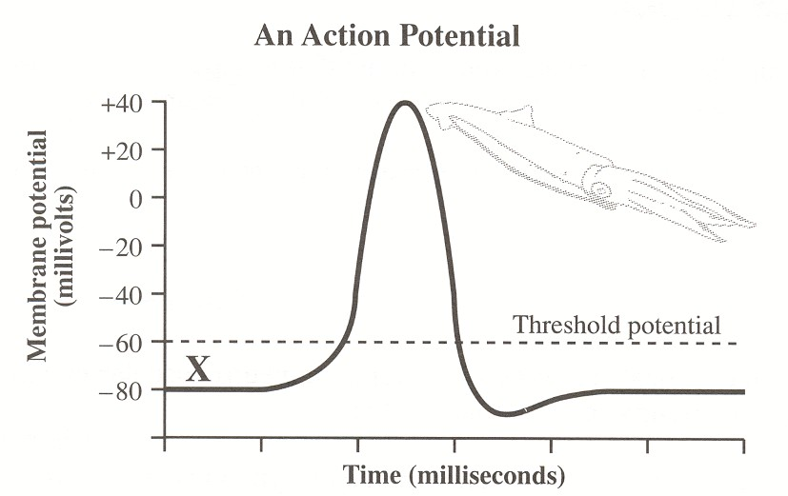

- Which of the following statements is true of the threshold potential?
- It is the same electrical potential for all neurons.
- It is the depolarization required to generate an action potential.
- It determines the time it takes for an action potential to be completed.
- It determines the time it takes for an impulse to travel along the axon.

- Relative to inside of a neuron, the extracellular fluid immediately outside a resting neuron’s cell membrane is
    - positive and the sodium ion concentration is less
    - negative and the sodium ion concentration is less
    - positive and the sodium ion concentration is greater
    - negative and the sodium ion concentration is greater

Use the following information to answer the next two questions.
Processes That Occur at a Neuromuscular Junction
(A Type of Synapse)

1 Muscle fibres contract when sodium gates open allowing sodium ions to diffuse into the
muscle cytoplasm.
2 Acetylcholine is released from the axon terminal.
3 Acetylcholine binds to the receptors on the muscle cell.
4 Cholinesterase breaks down acetylcholine, and the sodium gates close.
—from Guyton

Numerical Response

2. An impulse arrives at an axon terminal that synapses with a muscle cell. Record
the processes in the order that they occur at the synapse.

(Record your four-digit answer in the numerical-response section of the answer sheet.)
Answer: ___2314_______

- Certain chemicals inhibit cholinesterase at neuromuscular junctions. The resulting muscular spasms occur because of the
  - depletion of cholinesterase in the presynaptic neuron
  - depletion of acetylcholine in the neuromuscular junction
  - accumulation of cholinesterase in the presynaptic neuron
  - accumulation of acetylcholine in the neuromuscular junction

Use the following information to answer the next question.
Twenty-two once-paralyzed rats can now move their hind legs and even take awkward steps.
Their damaged spinal cords have been partially repaired by surgically grafting nerve fibres
from another part of their bodies to the damaged area.
—from Flam

- The division of the nervous system that was damaged in these rats is the
  - central nervous system
  - somatic nervous system
  - sympathetic nervous system
  - parasympathetic nervous system

Use the following information to answer the next three questions.

Neurons

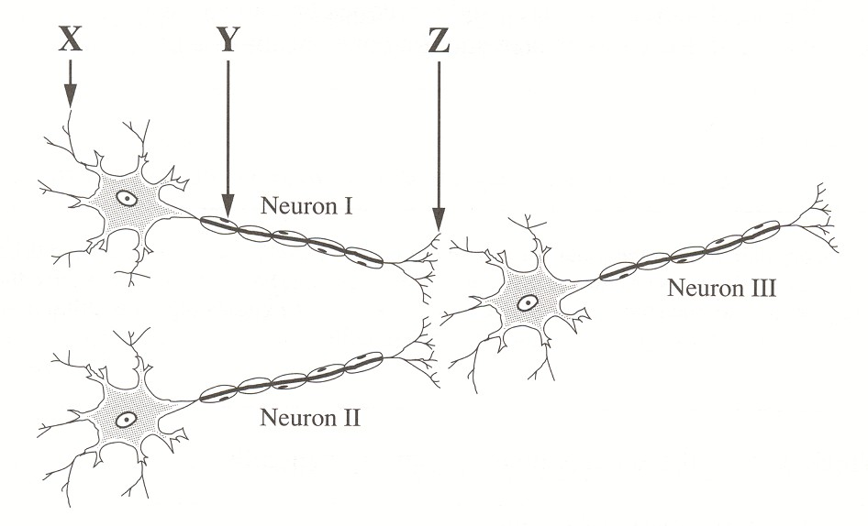

- Neurotransmitters are released from
  - site X
  - site Z
  - sites X and Y
  - sites X and Z

- If neurons I and II are interneurons, neuron III cannot be a
  - parasympathetic neuron
  - sympathetic neuron
  - sensory neuron
  - motor neuron

- In a typical reflex arc, neuron III would be part of the
  - effector
  - receptor
  - motor pathway
  - sensory pathway

- When adaptation of the eye occurs to view objects in a dark room,
      - the pupil increases in size and the rods become active
      - the pupil decreases in size and the rods become active
      - the pupil increases in size and the cones become active
      - the pupil decreases in size and the cones become active

Use the following information to answer the next question.
Sensory hair cells in the inner ear can be damaged by excessive noise or certain drugs. This
may cause deafness or balance disorders. Research suggests that these cells have the ability to
regenerate. In one study, the damaged inner ear tissue of guinea pigs was cultured in a dish.
The damaged tissue produced new sensory hair cells.
_from Gutin

- Which parts of the ear contain these sensory hair cells?
  - Auditory nerve and cochlea
  - Eardrum and auditory nerve
  - Eustachian tube and eardrum
  - Cochlea and semicircular canals
__________________________
Use the following information to answer the next question.

Control of the Secretion of Hormone Y by the Pituitary Gland

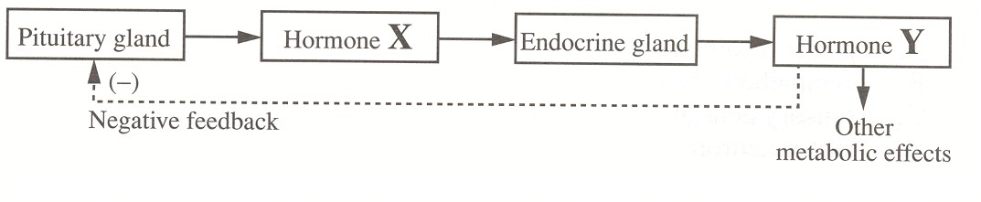

- Normally, inhibition of the pituitary gland would occur if the secretion of hormone X
  - increased, causing a decrease in the secretion of hormone Y
  - decreased, causing a decrease in the secretion of hormone Y
  - increased, causing an increase in the secretion of hormone Y
  - decreased, causing an increase in the secretion of hormone Y

Use the following information to answer the next two questions.
Stressful situations trigger the release of hormones such as cortisol. Recent studies have found
that some forms of depression cause a similar hormonal response that lasts much longer than
the normal stress response. This unregulated release of stress hormones may result in reduced
appetite, an unresponsive immune system, inadequate tissue repair, and insomnia.

- Another stress hormone whose functions mimic those of the sympathetic nervous system is
  - HCG
  - insulin
  - estrogen
  - norepinephrine

Use the following additional information to answer the next question.

A dog with a malfunctioning pituitary gland received injections of ACTH. Data were
collected after the dog’s injections.

—from Ganong

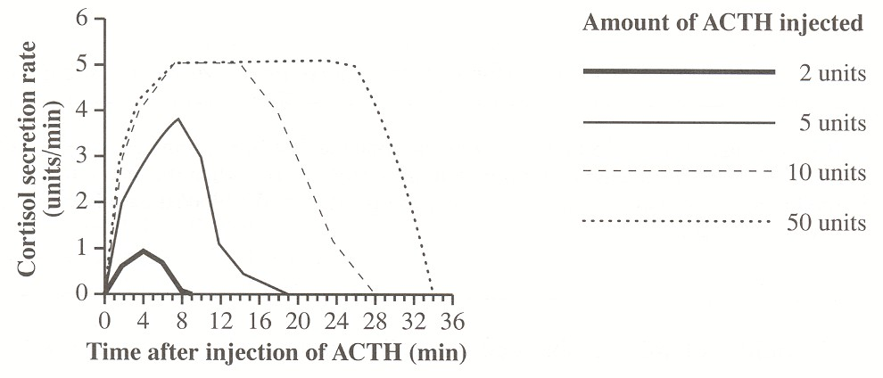

- A logical interpretation of the graph is that the
  - secretion of cortisol is inhibited by increased ACTH
  - secretion of cortisol is doubled if the secretion of ACTH is doubled
  - adrenal glands respond more quickly to small amounts of ACTH than to large amounts of ACTH
  - adrenal glands respond to large amounts of ACTH by having a maximum cortisol secretion rate

Use the following information to answer the next question.
In 1947, E. B. Verney published the results of a series of experiments that he had conducted
on a number of dogs. He found that if he injected a concentrated salt solution into the
bloodstream, hypothalamus, and ventricles of the brain, hormone “X” was released in large
amounts.

- Hormone “X” was most likely
  - ADH
  - ACTH
  - oxytocin
  - aldosterone
__________________________

- The endocrine function of the pancreas was studied in Canada using dogs as experimental animals. The pancreatic cells with an endocrine function are
  - islet cells
  - blood cells
  - Sertoli cells
  - interstitial cells

Use the following information to answer the next two questions.
Bovine somatotropin (BST) is a growth hormone that has been produced using biotechnology
since 1970. BST increases milk production by 10% to 20% when injected into milkproducing
cows. BST increases nutrient absorption from the bloodstream into the cow’s
mammary gland.
–from Harpp and Joseph

- BST could probably be obtained naturally from which gland in a cow?
  - Thyroid
  - Adrenal
  - Pituitary
  - Pancreatic

- In a cow’s mammary gland, BST is most similar in its effect to
- estrogen
- oxytocin
- prolactin
- progesterone
__________________________

- In humans, when iodine levels are adequate, abnormally high TSH secretion would likely result in
  - nervousness and weight gain
  - nervousness and weight loss
  - sleepiness and weight gain
  - sleepiness and weight loss

Use the following information to answer the next question.
Several studies have indicated that sperm counts in humans have declined over the past 25
years. Increased levels of chemicals in the environment that mimic estrogen have been found
in substances ranging from detergents to plastic wrappers. These chemicals are a suspected
cause of the decline in sperm counts.
—from Stainsby

- Males exposed to high levels of these estrogen-mimicking chemicals could experience
- development of breasts
- development of ovaries
- increased growth of muscles
- increased growth of facial hair

Jan 1999

Use the following information to answer the next question.

In an experiment, four stimuli of increasing strengths were applied to the membrane of an axon.
The graph below illustrates the change measured in the membrane potential of the neuron for each stimulus.

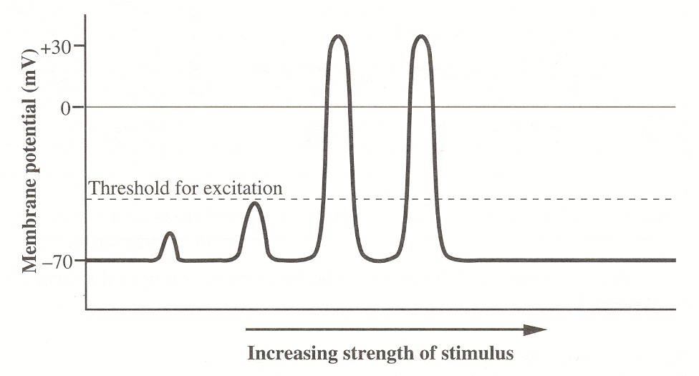
.

- Which of the following statements gives an accurate interpretation of the results of this experiment?
- Most stimuli produce a nerve impulse.
- A nerve impulse has a variety of strengths.
- A stimulus must reach a threshold level to initiate a nerve impulse.
- The greater the stimulus, the greater the strength of the nerve impulse produced.

Use the following information to answer the next question.

Nerve Impulse Transmission

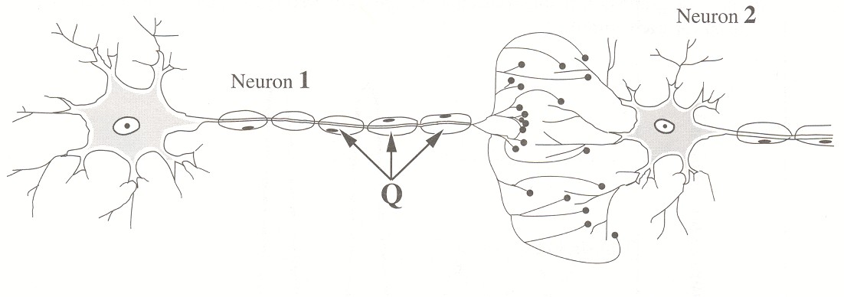

- If the structures labeled Q were absent, what effect on neural transmission would be expected?
- The axon would not release acetylcholine.
- The axon would be not become depolarized.
- The speed of transmission would be reduced.
- Cholinesterase would not be secreted to deactivate acetylcholine.

Use the following information to answer the next question.
The disease myasthenia gravis causes a person to experience muscular weakness because of
the failure of neuromuscular junctions to transmit signals from nerve fibres to muscle fibres.
The weakness is due to a reduced sensitivity to acetylcholine, which is necessary to stimulate the muscle fibre. People suffering from this disease are often treated with neostigmine, an anticholinesterase drug, which can result in some normal muscular activity within minutes.
—from Guyton and Hall, 1996

- Neostigmine is effective in treating this disease because it
- binds with cholinesterase to form acetylcholine
- binds with cholinesterase to increase acetycholine production
- reduces the amount of active cholinesterase, thereby increasing the amount of acetylcholine available to stimulate muscle contraction
- increases the amount of active cholinesterase, thereby increasing the amount of acetylcholine available to stimulate muscle contraction

Use the following information to answer the next question.

Observations About a Synapse and Synaptic Transmission

- Only axon terminals release neurotransmitters.
- A neurotransmitter diffuses from an axon terminal across the synapse to the dendrites or cell body.
- Many transmissions across a synapse in a short time may cause fatigue of synaptic transmission.
- Electron micrographs of a synapse show that there is no direct connection between the axon terminal of a presynaptic neuron and the dendrites or cell body of a postsynaptic neuron.

- The assumption that axon terminals contain a limited amount of neurotransmitter could account for observation
- 1
- 2
- 3
- 4

Use the following information to answer the next question.

A Simple Reflex Arc

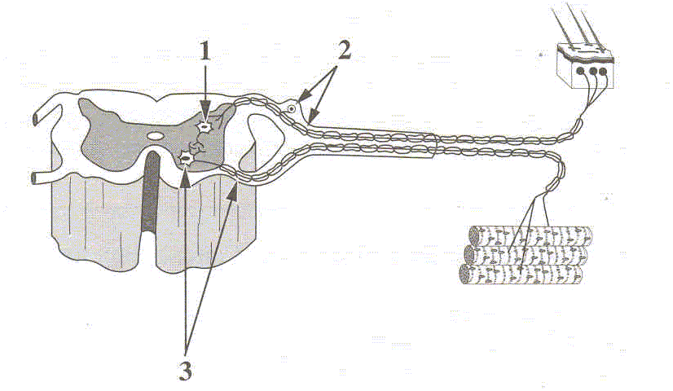

- Structure 1 is an interneuron. Structures 2 and 3 are, respectively, a
- sensory neuron and a motor neuron
- motor neuron and a sensory neuron
- non-myelinated neuron and a myelinated neuron
- myelinated neuron and a non-myelinated neuron

Use the following information to answer the next question.
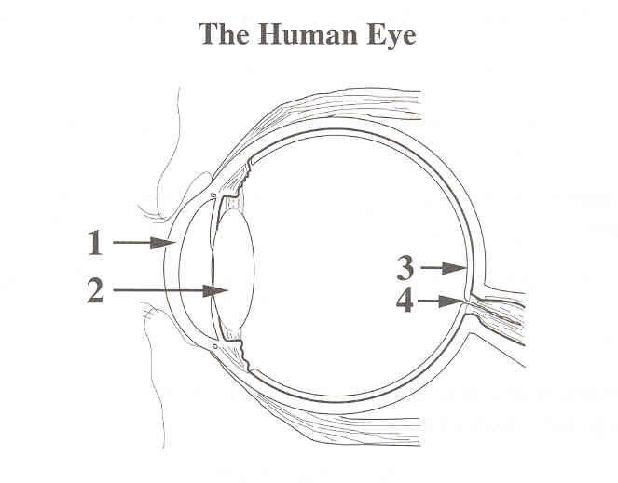

- An area of the eye where sensory reception of light is most acute and an area where there is no such sensory reception are labeled, respectively,
- 1 and 2
- 2 and 3
- 3 and 4
- 4 and 1

Use the following information to answer the next question.
Some people experience motion sickness when they travel in a boat, airplane, or automobile.
Symptoms include nausea, vomiting, dizziness, and headache. A drug can be taken to reduce these symptoms.

- Likely, this drug inhibits the transmission of information from the
- cochlea to the brain
- organ of Corti to the brain
- basilar membrane to the brain
- semicircular canals to the brain

- During an emergency situation, the adrenal gland is stimulated to release a hormone that directly causes an increase in
- insulin levels
- blood glucose levels
- parasympathetic stimulation
- conversion of glucose to glycogen

- Returning involuntary body functions to normal after a period of stress is the function of which division of the nervous system?
- Central
- Somatic
- Sympathetic
- Parasympathetic

Use the following information to answer the next question.
A tumour of the adrenal medulla is called phenochromocytoma. This tumour causes hypersecretion of epinephrine and norepinephrine, and a number of other symptoms.

- Possible symptoms of phenochromocytoma include
- increased heart rate, increased blood sugar, increased metabolic rate
- decreased heart rate, increased blood sugar, increased metabolic rate
- increased heart rate, decreased blood sugar, decreased metabolic rate
- decreased heart rate, decreased blood sugar, decreased metabolic rate

- A hormone that regulates glucose levels in the blood and a hormone that regulates Na+ in the blood and, indirectly, water reabsorption by the kidneys are, respectively,
- aldosterone and insulin
- glucagon and aldosterone
- epinephrine and glucagon
- insulin and antidiuretic hormone

- A condition that results in an enlargement of the thyroid gland may be caused by a diet deficient in
- iron
- iodine
- sodium
- potassium

Use the following information to answer the next question.
The following procedures and observations were used to determine the function of secretions
from an animal organ suspected of being an endocrine gland.

- The suspected endocrine gland was surgically removed from the animal.
- Symptoms in the animal were observed.
- A chemical mixture was extracted from the suspected endocrine gland.
- The chemical mixture was injected into the animal.
- Symptoms in the animal were no longer observed.
- Normal female rats injected with the chemical mixture showed accelerated body growth
- and increased estrogen production.

- Based on these observations, the organ was
  - an ovary
  - the pancreas
  - an adrenal gland
  - the pituitary gland

Jan 2000

Use the following information to answer the first two questions.
A group of psychologists wondered if inhaling pure oxygen could enhance a person’s mental
capacity. They tested forty-five students.

These students breathed through a face mask for one minute. They were either given pure
oxygen or normal air, but they did not know which. Those receiving pure oxygen could recall
twice as many words as those receiving normal air.
—from Mihill, 1996

- The part of the brain that is directly responsible for the recall of previously learned words is the
  - cerebrum
  - cerebellum
  - pituitary gland
  - medulla oblongata

- The part of the brain that controls the unconscious rate of breathing is the
- cerebrum
- cerebellum
- pituitary gland
- medulla oblongata

Use the following information to answer the next two questions.
Movement of hair cells in normal ears opens tiny pores called ion channels in the nerve cell
membrane. This process begins impulse transmission along the auditory nerve.

- Nerve impulse transmission continues along the nerve cell membrane as
  - a wave of depolarization
  - a negative feedback loop
  - a diffusing wave of summation
  - the active transport of an electrical potential

- The part of the ear directly responsible for stimulating the nerve endings that transmit sound impulses from the ear to the brain is the
  - cochlea
  - eardrum
  - Eustachian tube
  - semicircular canal

Use the following information to answer the next two questions.
Many predatory birds such as eagles have two foveas in each eye. The fovea in predatory
birds is similar in structure and function to the fovea in humans. In addition, these birds have
strong powers of near and far accommodation.
—from Curtis, 1983

- If an eagle’s brain were similar in structure to a human brain, impulses that begin in the retina of the eagle’s eye would travel first to the
  - frontal lobe
  - parietal lobe
  - occipital lobe
  - temporal lobe
- Strong near and far accommodation in the eye require
- small blind spots
- a large number of rods
- a large number of cones
- highly developed ciliary muscles

Use the following diagram to answer the next question.

—from Marieb, 1987
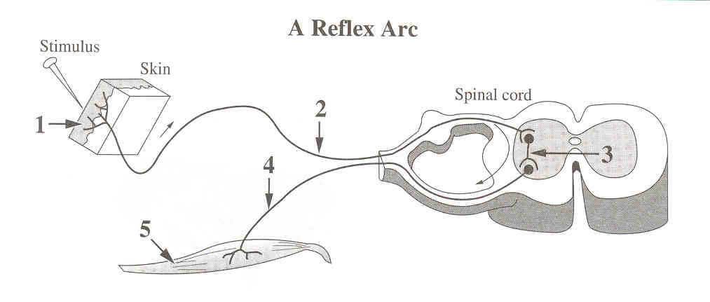

Numerical Response

3. Identify the structure, as numbered above, that performs each of the functions given
below.

Structure: ____2______ ____1______ ___5_______ ______4____
Function: Transmits impulses Receives sensory Carries out Transmits impulses
to the central stimulation instructions from from the central
nervous system the central nervous nervous system to
system; is a the effector
muscle

(Record your four-digit answer in the numerical-response section on the answer sheet.)

- Jogging will cause heart rate to change because of
  - increased sympathetic and decreased parasympathetic impulses
  - decreased sympathetic and increased parasympathetic impulses
  - increased sympathetic and decreased central nervous system impulses
  - decreased sympathetic and increased central nervous system impulses

- Damage to which of the following endocrine glands would most affect the reaction of the body to an emergency that stimulates the sympathetic nervous system?
      - Thyroid gland
      - Adrenal gland
      - Anterior pituitary gland
      - Posterior pituitary gland

Use the following information to answer the next question.
Oxytocin and ADH are synthesized by neurosecretory cells in the hypothalamus. These
hormones are stored in the posterior pituitary. They can then be released into the bloodstream
where they circulate to target cells.

Hormones of the Pituitary and Hypothalamus

—from Campbell, 1987

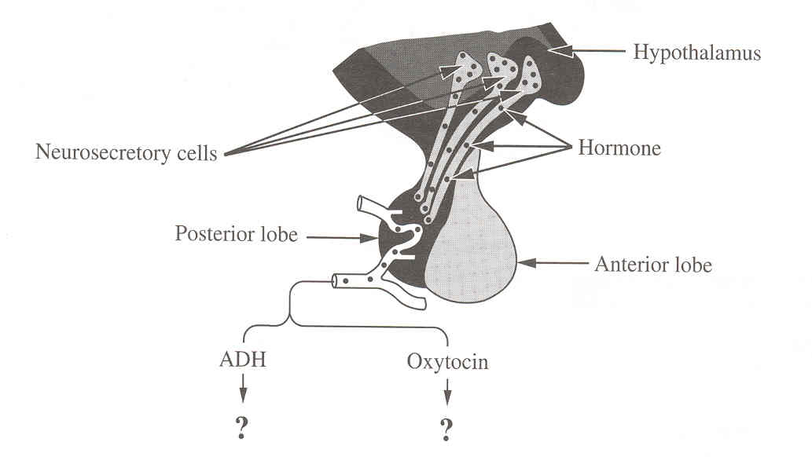

- In a human female, where are the target cells for ADH and oxytocin?

  - In the kidney tubules and ovaries
  - In the Bowman’s capsule and the ovaries
  - In the kidney tubules and uterine muscles
  - In the Bowman’s capsule and the uterine muscles
Use the following information to answer the next question.
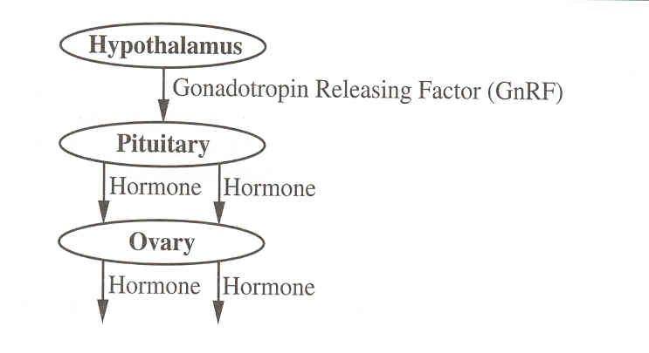

- In humans, high levels of GnRF cause the pituitary to release

  - LH and FSH
  - LH and estrogen
  - progesterone and FSH
  - estrogen and progesterone

Use the following information to answer the next question.

Responses Stimulated by Hormones

1 Release of thyroxine 4 Development of follicle and sperm
2 Development of bones and muscles 5 Ovulation and maintenance of the corpus luteum
3 Water reabsorption by kidneys 6 Milk production

Numerical Response
4. 2. Identify the response, as numbered above, that would be stimulated by each of the
hormones given below.

Response: _____2_____ ____5______ ___1_______ ____4______
Hormone: STH(HGH) LH TSH FSH

(Record your four-digit answer in the numerical-response section on the answer sheet.)

Jan 2001

Use the following information to answer the first question.

After accidentally hitting your thumb with a hammer, you immediately withdraw your hand.
You do not feel pain for a short period of time.

- This sequence of events may be explained by the fact that the
  - threshold of the receptor has been so greatly exceeded that the neuron does not pass the message to the brain
  - neural impulse is so large that the brain is unable to interpret the signal because it is beyond the range of tolerance
  - neural processing occurred in the spinal cord first, which caused you to quickly remove your thumb from further damage
  - sensory receptors in the thumb were damaged by the blow and are unable to initiate a stimulus to the sensory nerve

- Stimulation of an individual’s sympathetic nervous system in response to imminent danger leads to all of the following responses except
      - dilation of the pupils of the eyes
      - constriction of the bronchioles of the lungs
      - constriction of the arterioles of the intestines
      - dilation of the arterioles of the skeletal muscles

Use the following information to answer the next question.
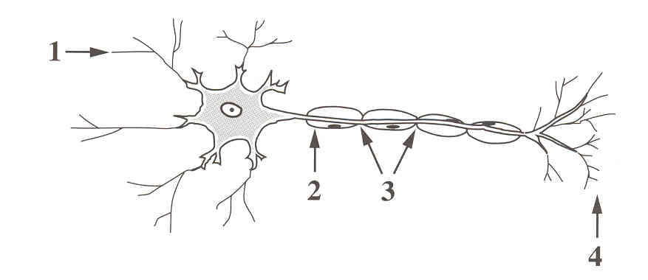

- The part of the motor neuron that may release acetylcholine is labelled
  - 1
  - 2
  - 3
  - 4

- What would happen if acetylcholine was released at a synapse, but no cholinesterase was present?
      - The acetylcholine would fail to stimulate the postsynaptic neuron.
      - The acetylcholine would diffuse more rapidly across the synaptic cleft.
      - A single nerve impulse would be generated in the postsynaptic neuron.
      - The postsynaptic neuron would remain in a constant state of depolarization.

Use the following information to answer the next question.
The brain neurotransmitter dopamine is linked to the good feelings associated with actions
such as receiving a friendly hug. When cocaine is present in synapses, it binds with dopamine
transporters producing similar emotional effects. Normally, dopamine transporters carry
dopamine back into the cells where it was formed.
—from Page, 1997

- Dopamine transmission is affected when dopamine transporters, which normally carry dopamine back to the cell that formed it, are occupied by cocaine. The effects of cocaine occur because dopamine
  - is produced in increased concentration
  - remains in the synapse in high concentration
  - levels drop rapidly as the molecules react with cocaine
  - is transported very effectively to the postsynaptic neuron

Use the following information to answer the next question.
Morphine is a drug obtained from the opium plant. It is routinely given to postoperative
patients on a short-term basis for pain. At high doses, it causes breathing and heart contraction
to become suppressed.

- What area of the brain is affected by high doses of morphine?
- Pituitary
- Cerebrum

Cerebellum
- Medulla oblongata

Use the following information to answer the next five questions.

A high percentage of purebred dogs have genetic defects. Some examples of these defects follow.

1 Hip dysplasia, a defect in the hip joints that can cripple a dog, occurs in 60% of golden retrievers.
2 Hereditary deafness, due to a recessive autosomal disorder, occurs in 30% of Dalmatians.
3 Retinal disease, which may cause blindness, occurs in 70% of collies.
4 Hemophilia, an X-linked recessive disorder, is common in Labrador retrievers. Dwarfism is also common in this breed of dog.
—from Lemonick, 1994

Use the following additional information to answer the next two questions.
Cross-Section of a Normal Eye

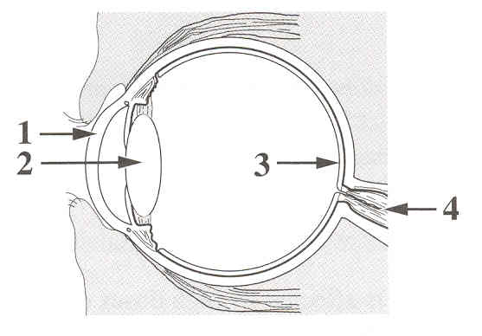

- The structure that degenerates and causes blindness in collies is
- 1
- 2
- 3
- 4

January 2002

Use the following information to answer the first three questions.
The thyroid gland secretes the hormones thyroxine and calcitonin. Embedded in the thyroid
gland are the four parathyroid glands. The parathyroid glands secrete the parathyroid hormone
(PTH). Calcitonin and PTH work antagonistically to maintain homeostasis of calcium ion
concentrations in the blood. High levels of calcium ions stimulate the secretion of calcitonin,
which causes deposition of calcium in the bones.

- Low levels of calcium ions in the blood cause
- decreased secretion of PTH and increased deposition of calcium in the bones
- decreased secretion of calcitonin and increased deposition of calcium in the bones
- increased secretion of PTH and movement of calcium from the bones to the blood
- increased secretion of calcitonin and movement of calcium from the bones to the blood

- The release of thyroxine from the thyroid is directly regulated by
- TSH
- TRH
- iodine

thyroxine

- A characteristic symptom of hyperthyroidism, a disorder of the thyroid gland, is

lethargy
  - weight loss
  - intolerance to cold
  - slowed mental processes

- Which of the following hormones plays a role in returning the salt concentration in the blood to homeostatic levels following heavy exercise?
      - Cortisol
      - Thyroxine
      - Aldosterone
      - Epinephrine

Use the following information to answer the next question.

Chemicals found in alcohol and tea have a diuretic effect. Diuretics cause the body to produce
greater-than-normal volumes of urine.

- Diuretic chemicals counteract the effect of the hormone
  - ADH
  - insulin
  - cortisol
  - prolactin
_______________________________

Use the following information to answer the next five questions.
Multiple sclerosis (MS), a disease of the nervous system, typically has symptoms of uncontrolled muscle responses, weakness, paralysis, and vision difficulties. Researchers believe that MS occurs as a result of the body’s immune system destroying the myelin sheath that surrounds the axon of a nerve cell. The result is a scarring of brain tissue or of spinal cord tissue.

- Damage to the myelin sheath of an optic neuron affects the speed of neural transmission to the visual centre, which is found in which lobe of the cerebrum?
  - Frontal lobe
  - Parietal lobe
  - Occipital lobe
  - Temporal lobe

Numerical Response
1. Another symptom of MS is an exaggerated pupillary light reflex. Some of the events that occur during this reflex are listed below.

1 Motor neuron depolarizes
2 Sensory neuron depolarizes
3 Interneuron depolarizes
4 Light receptors stimulated

The order in which the events listed above occur during a pupillary light reflex
is __4___, __2___, __3___, and __1___.

(Record all four digits of your answer in the numerical-response section on the answer sheet.)

Use the following additional information to answer the next three questions.
Stimulation of a sensory neuron produces an action potential. An abnormal pattern in this action
potential can be used to detect MS in its early stages. The graph below illustrates the membrane
potential of a normal neuron after stimulation.

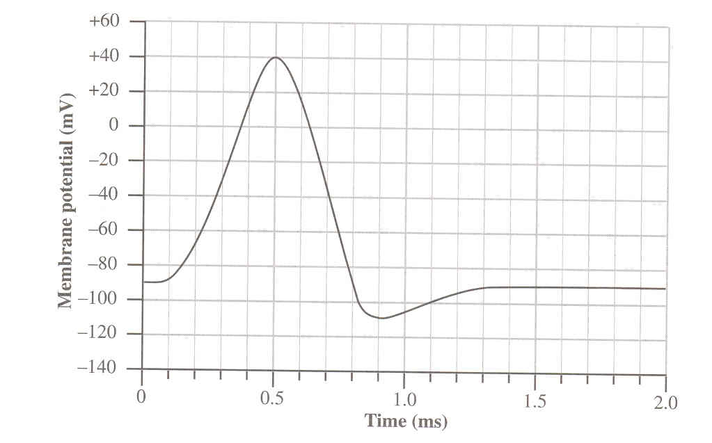

Numerical Response
2. What is the resting membrane potential for this neuron, expressed to two digits,
and what is the maximum membrane potential during depolarization, expressed to
two digits? (Record your answers as absolute values.)
Answers: __9___ _0____ , __4___ __0___
Membrane Potential: Resting Maximum
During
Depolarization

(Record all four digits of your answer in the numerical-response section on the answer sheet.)

- Which of the following types of ion movement across an axon membrane would cause the action potential to change during the interval from 0.2 ms to 0.4 ms?
  - Sodium ions moving into the axon
  - Sodium ions moving out of the axon
  - Potassium ions moving into the axon
  - Potassium ions moving out of the axon

- On the graph, the period from 0.5 ms to 1.0 ms represents the neuron’s
  - refractory period, which is when repolarization occurs
  - refractory period, which is when minimum depolarization occurs
  - threshold period, which is when repolarization occurs
  - threshold period, which is when minimum depolarization occurs

Use the following information to answer the next four questions.
Monoamine oxidase (MAO) is an enzyme that breaks down the neurotransmitters dopamine,
serotonin, and norepinephrine. Individuals who are involved in extreme sports, such as rock
climbing, generally have low levels of MAO and, therefore, higher-than-normal levels of these
neurotransmitters.

Dopamine and serotonin are linked to pleasurable feelings. Norepinephrine is released in the
fight-or-flight response. One hypothesis for why individuals participate in extreme sports is
that in order for individuals with high resting levels of these neurotransmitters to achieve a
pleasurable sensation, they require a greater surge of these chemicals than do other people.

—from Zorpette, 1999

- The site in the neural pathway where MAO is active is the
  - axon
  - synaptic cleft
  - cell body
  - Schwann cell

    - The area of the brain that normally initiates the fight-or-flight response is the
- pons
- cerebrum
- cerebellum
- hypothalamus

Use the following additional information to answer the next two questions.
Serotonin stimulates the release of endorphins, and endorphins eventually cause the release of
more dopamine. Studies of individuals involved in extreme sports have found that these
people have lower-than-normal numbers of two of the five types of dopamine receptors.

—from Zorpette, 1999

- The endorphin met-enkephalin is comprised of the amino acids methionine, phenylalanine, glycine, glycine, and tyrosine. Possible mRNA codons for the production of met-enkephalin are
- ATG TTT GGT GGT TAT
- ATG TTG GGC GGC TAT
- AUG UUC GGT GGT UAC
- AUG UUU GGC GGC UAC

- When individuals participate in extreme sports, their neurons release more dopamine, which results in a pleasurable sensation because
- less serotonin is released from neurons
- more dopamine receptors are produced
- the fight-or-flight response is inhibited
- a neuron containing dopamine receptors reaches threshold depolarization

