BIO 30 GENETICS January Diploma Exam Questions

JANUARY 1996

Use the following information to answer the next two questions.
Based on the principles of genetics and the analysis of cells produced by meiosis, it is
predicted that male and female humans should be produced in equal numbers. However, the
ratio of the number of males to females, known as the sex ratio, changes throughout the life
cycle. The sex ratio at conception (comparing the number of “male” zygotes to “female”
zygotes) is often as high as 1.6 to 1 in favour of males. The sex ratio at birth is 1.05 to 1 in
favour of males. In adults aged 20 to 25 years, the sex ratio is 1 to 1. After age 25, the sex
ratio shifts in favour of females.

- Which row correctly identifies one genetic factor and one environmental factor that might cause the described changes in the sex ratio?
Row | Genetic Factor | Environmental Factor
A. | X-linked disorders affect  more males than females. | A male pre-embryo has a greater chance of  successful implantation than a female preembryo.
B. | X-linked disorders affect  more females than males. | A male pre-embryo has a greater chance of  successful implantation than a female preembryo.
C. | X-linked disorders affect  more males than females. | Accidents are the leading cause of death  among males aged 15 to 35 years.
D. | X-linked disorders affect  more females than males. | Accidents are the leading cause of death  among males aged 15 to 35 years.

- Which statement provides the best explanation for the underlying cause of the sex ratio at conception?
  - Sperm that contain an X chromosome are more motile than those that contain a Y chromosome.
  - Sperm that contain a Y chromosome are more motile than those that contain an X chromosome.
  - There is a greater probability that males will produce sperm that contain an X chromosome than those that contain a Y chromosome.
  - There is a greater probability that males will produce sperm that contain a Y chromosome than those that contain an X chromosome.

Use the following information to answer the next two questions.

Some Inherited Traits in House Cats

Dominant Trait Allele Recessive Trait Allele
Pointed ears P Folded ears p
Smooth hair S Curly hair s
Polydactyly (more D Five digits on paws d
than 5 digits on
paws)

Assume that all of the alleles shown above exhibit independent assortment.

- A folded-eared female mated with a male of unknown phenotype. All six of their offspring had pointed ears. What were the most probable genotypes of the parents?
  - pp and PP
  - Pp and Pp
  - pp and Pp
  - pp and pp

Numerical Response
07. A curly-haired, five-digited male was crossed with a female that was heterozygous
for both hair type and the number of digits on the paws. What is the probability of
this mating producing offspring that have curly hair and are heterozygous for the
number of digits on the paws?

(Record your answer as a value from 0 to 1, rounded to two significant digits, in the numerical response
section of the answer sheet.)

Answer: __0.25_____

Use the following information to answer the next two questions.
In Drosophila, ebony body colour is caused by the recessive allele eb and grey body colour by
the dominant allele eb+. Vestigial wings are produced by the recessive allele vg and long
wings by the dominant allele vg+.

When mated, a female with ebony body colour and vestigial wings produced the following
offspring:

41 flies with ebony body and long wings
44 flies with grey body and long wings
39 flies with grey body and vestigial wings
46 flies with ebony body and vestigial wings

- What was the genotype of the male parent in this cross?
  - eb+eb+ vg+vg+
  - eb+eb vg+vg+
  - eb+eb vg+vg
  - eb+eb vgvg

- How many of the 44 offspring with grey bodies and long wings would be expected to be heterozygous for body colour?
  - 44
  - 33
  - 22
  - 11

Use the following information to answer the next two questions.
An anemic condition in humans called thalassemia results from decreased production of
hemoglobin. Three genes control the condition: N (normal hemoglobin), Thal-1 (thalassemia 1),
and Thal-2 (thalassemia 2). Possible genotypes and phenotypes for the trait are shown below.

Genotype Phenotype
NN No anemia
N Thal-1 Mild anemia
N Thal-2 Mild anemia
Thal-2 Thal-2 Mild anemia
Thal-2 Thal-1 Moderate anemia
Thal-1 Thal-1 Fatal—embryo or fetus dies before birth

- Which statement is consistent with the information given?
  - Thal-1 and Thal-2 are codominant and N is dominant.
  - Thal-1 is dominant over both N and Thal-2.
  - N is dominant over both Thal-1 and Thal-2.
  - N, Thal-1, and Thal-2 are codominant.

    - If a male with the genotype N Thal-1 and a female with the genotype N Thal-2 have a child, the probability of that child having some degree of anemia (either mild or moderate) is
      - 1.00
      - 0.75
      - 0.50
      - 0.25

Use the following information to answer the next TWO questions.
The human nose can distinguish up to 10 000 different odours. Airborne odour molecules are
trapped by ciliated olfactory receptors. These receptors initiate impulses to the olfactory
bulbs, which relay the signals to the temporal lobe of the cerebrum for interpretation.

Recently, researchers Linda Buck and Richard Axel of Columbia University have been able to
identify some odour-receptor proteins on the nasal cells of rats. These receptor proteins,
embedded in the cell membranes of ciliated neurons, are thought to bind with specific odour
molecules, initiating a nerve impulse. The researchers have also found the genes responsible
for the production of more than 100 types of odour-receptor proteins.

- The ability to smell some odours and not others is an inherited trait. This trait is an example of
  - incomplete dominance
  - crossing over
  - a phenotype
  - a genotype

- If a gene responsible for the production of an odour-receptor protein underwent a mutation, one result might be
  - a decrease in the ability to smell a specific odour
  - an increase in the ability to smell a variety of other odours
  - a decrease in protein synthesis within all olfactory neurons
  - an increase in threshold levels of stimulation for receptor neurons

Numerical Response
08. Czar Nicholas II was not a hemophiliac. His wife, Alexandra, was a carrier for
hemophilia. What was the probability that any of their daughters was a carrier
for hemophilia?

(Record your answer as a value from 0 to 1, rounded to two significant digits, in the numericalresponse
section of the answer sheet.)

Answer: __0.50_____

January 1997

Use the following information to answer the next question.
When conducting his research into the genetics of pea plants, Gregor Mendel crossed
true-breeding, yellow-seeded plants with true-breeding, green-seeded plants. He observed
that all of the F1 generation had yellow seeds.

- In the F1 generation, the allele for yellow seeds would have been found in
  - about 50% of the female gametes and 50% of the male gametes produced by F1 plants
  - all of the female gametes and none of the male gametes produced by F1 plants
  - all of the male gametes and none of the female gametes produced by F1 plants
  - none of the male gametes or female gametes produced by F1 plants

Use the following information to answer the next three questions.

Some Traits in Garden Pea Plants
In pea plants, the genes for seed shape, seed colour, and plant height demonstrate independent
assortment. The alleles for these genes are symbolized as follows:

Seed shape — R (round) > r (wrinkled)
Seed colour — Y (yellow) > y (green)
Plant height — T (tall) > t (short)

- The phenotypic ratio of a cross between YyTt pea plant and a yyTt pea plant is
  - 3 yellow tall : 3 yellow short : 1 green tall : 1 green short
  - 1 yellow tall : 1 yellow short : 1 green tall : 1 green short
  - 3 yellow tall : 1 yellow short : 3 green tall : 1 green short
  - 1 yellow tall : 1 yellow short : 3 green tall : 3 green short

    - In a cross between an RrYy plant and an RRYY plant, what fraction of the offspring would be expected to have the genotype RRYy?
      - 1/2
      - 1/4
      - 3/8
      - 1/8

Numerical Response
05. What percentage of the gametes produced by a pea plant heterozygous for both
seed shape and seed colour would be expected to contain both the allele for
wrinkled and the allele for green?

(Record your answer as a whole number in the numerical-response section of the answer sheet.)
Answer: ____25_______%

Use the following information to answer the next question.
A sweet pea plant variant was found that has purple flowers. When this plant was self-pollinated,
the following F1 offspring were produced.

Phenotype Number of Offspring

Pink flowers 30
Purple flowers 62
Burgundy flowers 33

- Which pattern of inheritance for flower colour is demonstrated by this sweet pea plant variant?
  - X-linked recessive
  - Autosomal recessive
  - Autosomal dominant
  - Incomplete dominance

Use the following information to answer the next question.
Huntington’s disease is a disorder in which two regions of the brain that help control body
movement are destroyed; therefore, the diseased body is in perpetual motion. Huntington’s
disease is thought to have originated as a single dominant gene mutation on chromosome 4
in a small population in northwestern Europe. The disease is spread through inheritance
since new mutations are very rare. One in every 10 000 people has the gene.

Numerical Response
06. A man who is heterozygous for the disease allele marries a woman who is
homozygous for the normal recessive allele. What is the probability that their first
child is a boy and has Huntington’s disease?

(Record your answer as a value from 0 to 1, rounded to two decimal places, in the numerical response
section of the answer sheet.)

Answer: _____0.25______

Use the following information to answer the next two questions.
Four babies were born in a hospital on the same day. Due to a mix-up at the hospital, there
was some confusion as to the identity of the babies.

Mother Father
Parents 1 Type A Type O
Parents 2 Type AB Type B
Parents 3 Type O Type B
Parents 4 Type AB Type O

Blood Type
Baby W Type A
Baby X Type B
Baby Y Type AB
Baby Z Type O

- Of the following, the parent and child combination that could be possible is
  - parents 1 and baby Y
  - parents 2 and baby Z
  - parents 3 and baby W
  - parents 4 and baby X

Numerical Response
01. The probability that a mother with blood type O and a father with the genotype IBi
would have a child with blood type O is __________.

(Record your answer as a value from 0 to 1, rounded to two decimal places, in the numericalresponse
section of the answer sheet.)

Answer: ___0.50________

Use the following information to answer the next two questions.
Green–blue–brown eye colour
The biochemistry of eye colour is not completely understood. Part of an explanation for eye
colour may be the interaction of the products of three different alleles. The green allele is
dominant to blue. The brown allele is also dominant to blue. The green is expressed only in
the absence of a brown allele.

Red–green colour blindness
Red–green colour blindness results from a mutation of an X-linked gene. A mutation in the
gene causes red–green colour blindness (Xcb), the inability to distinguish between red and
green. The Xcb allele is recessive.

Legend: B—brown eye colour allele
b—blue eye colour allele
G—green eye colour allele
Xcb—colour-blindness allele
X—normal vision allele

- A colour-blind male with brown eyes and his green-eyed wife who has normal colour vision have a daughter who is colour-blind and has blue eyes. What is the genotype of this child?
  - XcbXcbBb
  - XcbXcbGb
  - XcbXcbbb
  - XcbYbb

Use the following additional information to answer the next question.

A Pedigree Indicating Colour Blindness in a Family

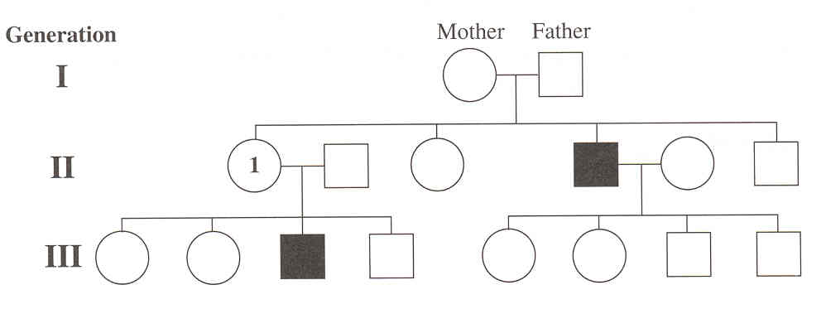

- If individual 1 has blue eyes, genotypes of her parents could be
  - mother XXbb, father XcbYGB
  - mother XXcbGb, father XYBb
  - mother XXcbGG, father XYbb
  - mother XXcbGb, father XcbYBB

Numerical Response
01. Three genes have been identified on chromosome two in Drosophila (fruit flies).
They control eye colour, body hair (bristles), and wing shape. The genes are:

1 cinnabar eyes
2 short bristles
3 curved wings

The crossover frequency between 1 and 3 is 18%, between 2 and 3 is 24.5 %, and
between 1 and 2 is 6.5%. Construct a gene map of three genes and indicate their
order by number.

(Record your three-digit answer in the numerical-response section of the answer sheet.)

Answer: _____213 OR 312______

Use the following information to answer the next question.
In Drosophila (fruit flies), straight wing (S) is dominant to curved wing (s). A curved-wing
female lays 200 eggs. The eggs hatch into larvae and they mature into adults, all with
straight wings.

- This information indicates that the genotype for the unknown male is likely
- homozygous
- heterozygous
- either homozygous recessive or heterozygous
- either homozygous dominant or heterozygous

JANUARY 1998

Use the following information to answer the next three questions.
Gregor Mendel examined the inheritance of two traits in pea plants: seed coat texture and
colour. Seed coat texture can be represented as S–smooth and s–wrinkled, and seed coat
colour can be represented as Y–yellow and y–green. SSYY plants were crossed with ssyy
plants to yield F1 pea seeds that were all smooth and all yellow. By crossing plants grown
from these F1 seeds, Mendel obtained four different phenotypes of F2 seeds:

• smooth and green seeds
• wrinkled and green seeds
• smooth and yellow seeds
• wrinkled and yellow seeds

- If the traits for seed coat texture and seed coat colour had been located close together on the same chromosome, Mendel might not have conceptualized
- gene pairs
- dominance
- the Law of Segregation
- the Law of Independent Assortment

Numerical Response
01. The F2 seed phenotype ratio that Mendel obtained upon crossing two heterozygous
smooth and yellow F1 individuals would have been __________.

(Record your four-digit answer in the numerical-response section of the answer sheet.)

Answer: ____3______ : ____1______ : ___9______ : ____3______
smooth and wrinkled and smooth and wrinkled and
green green yellow yellow

Use the following additional information to answer the next question.
Mendel selected two varieties of pea plants from seeds he had grown. One variety of peas
came from a field planted with smooth, yellow seeds. Another variety of peas came from a
field planted with wrinkled, green seeds. These two varieties of peas were crossed to produce

255 plants with smooth and green seeds
268 plants with wrinkled and green seeds
237 plants with smooth and yellow seeds
240 plants with wrinkled and yellow seeds

From the phenotype ratio of the offspring, Mendel deduced that the smooth and yellow parents
had the genotype YySs.

- This type of cross is referred to as a
- test cross
- monohybrid cross
- homozygous cross
- heterozygous cross

Use the following information to answer the next two questions.
In Labrador retriever dogs, two alleles, B and b, determine whether the coat colour will be
black (B) or brown (b). Black coat colour is dominant. A second pair of alleles, E and e, are
on a separate chromosome from B and b. The homozygous recessive condition, ee, prevents
the expression of either allele B or b and produces a dog with a yellow-coloured coat. Some
examples of genotypes and phenotypes for Labrador retrievers are shown below.

Genotype Phenotype
BBEe black
BbEe brown
Bbee yellow
—from Davol

- What is the probability of obtaining a black puppy from the following cross?

BbEe x BbEE

- 9/16
- 3/16
- 3/4
- ¼

Numerical Response
02. Two dogs, each with the genotype BbEe, were crossed. What is the percentage
probability that their offspring would have yellow coat colour?

(Record your answer as a whole number percentage in the numerical-response section of the
answer sheet.)

Answer: __25____

Use the following information to answer the next question.
A recessive allele causes Drosophila to have white eyes instead of wild-type eyes. This
eye colour gene is known to be X-linked. In a cross between homozygous wild-type females
and white-eyed males, all F1 progeny have wild-type eyes.

- What ratio of wild-type to white-eyed progeny can be expected in each sex if F1 females are crossed to males of the same genotype as their father?
- Males – 1:0, females – 1:0
- Males – 1:1, females – 1:0
- Males – 0:1, females – 1:1
- Males – 1:1, females – 1:1
__________________________

Use the following information to answer the next question.

Crossover Frequencies for Some Genes on Drosophila Chromosome One

Crossover
Genes Frequency
White eyes (w) and Facet eyes (f) 1.5%
White eyes (w) and Echinus eyes (e) 4.0%
White eyes (w) and Ruby eyes (r) 6.0%
Facet eyes (f) and Echinus eyes (e) 2.5%
Facet eyes (f) and Ruby eyes (r) 4.5%

- The crossover frequency between genes e and r is
- 3.5%
- 2.0%
- 1.5%
- 0.5%

Use the following information to answer the next two questions.
Locations of Some Genes on a Section of a Drosophila Chromosome
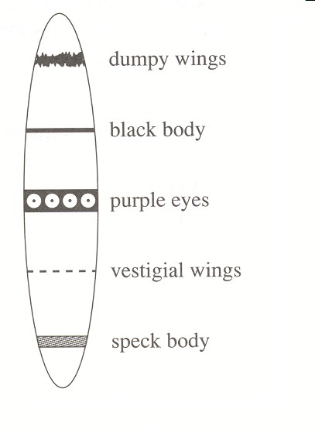

- During meiosis, which pair of genes have the best chance of being transferred together to a new cell?
- Black body and purple eyes
- Purple eyes and speck body
- Dumpy wings and purple eyes
- Dumpy wings and speck body

  - To determine whether this is an X chromosome or an autosome, a researcher would have to determine whether these traits are
    - recessive
    - dominant
    - passed from male parents to their male offspring
    - passed from female parents to their male offspring

Use the following information to answer the next two questions.
A Pedigree Showing the Incidence of ABO Blood Types in a Family

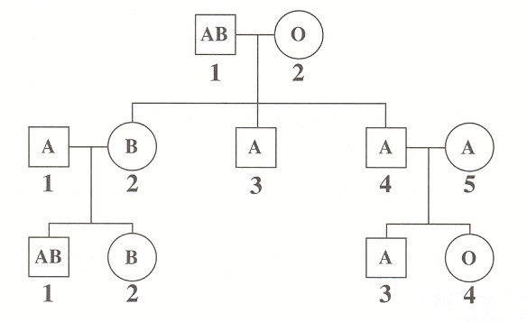

I

II

III

- Which individual is a known homozygote for blood type?
  - I_1
  - I_2
  - II_2
  - II_3

    - Which of the following rows correctly identifies the genotypes of individuals III-2 and III-3?

Row | Individual III-2 | Individual III-3
A. | IBi or IBIB | IAi
B. | IBi | IAi or IAIA
C. | IBi or IBIB | IAi or IAIA
D. | IBi | IAi

JANUARY 1999

Use the following information to answer the next two questions.
The gene for a light-sensitive protein found in red cones and the gene for a light-sensitive
protein found in green cones lie side by side on the X chromosome. A third gene for a lightsensitive
protein found in blue cones was discovered on chromosome 7. Mutations to any of
these genes result in the common forms of colourblindness. The mutant alleles for these
disorders are recessive.

- A valid assumption based on this information is that
  - all types of colourblindness are sex-influenced
  - males may be carriers for all types of colourblindness
  - only females may be carriers for blue colourblindness
  - blue colourblindness occurs in males and females with equal frequency

Use the following additional information to answer the next question.

Pedigree of Red–Green Colourblindness in Humans

Note: Heterozygous individuals have not been identified. The phenotype of III-2 is unknown.

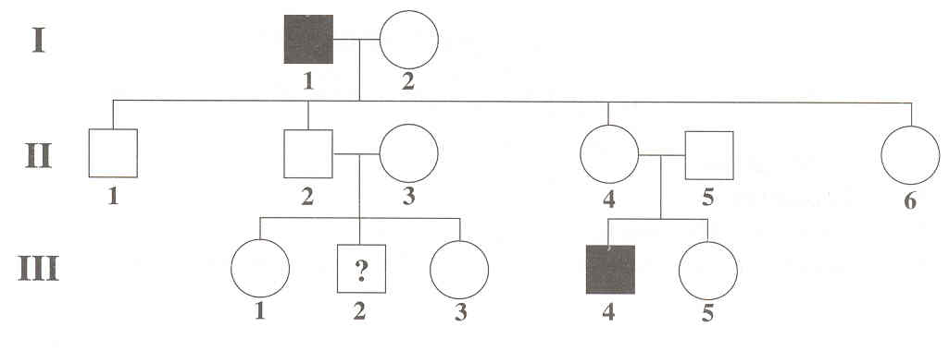

- Based on this pedigree,
  - the probability that individual II-4 is a carrier is 50%
  - it is impossible to determine whether individual II-6 is a carrier
  - if individual III-5 is a carrier, all of her female children will have red–green colourblindness
  - if individual II-3 is a carrier, there is a 50% chance that her male child will have red–green colourblindness

Use the following information to answer the next question.
The use of marker genes and the analysis of crossover frequencies of genes have enabled
geneticists to map the location of many genes on human chromosomes. Blue colour vision and
blue colourblindness (tritanopia) are controlled by a gene on chromosome 7. The gene for the
production of trypsin (a digestive enzyme) and the gene responsible for cystic fibrosis are also
found on chromosome 7. Some crossover frequencies of these genes are shown below.

Pair of Genes Crossover Frequency

Marker gene — cystic fibrosis 18%
Marker gene — tritanopia 13%
Cystic fibrosis — trypsin 6%
Trypsin — tritanopia 1%
—from Rimoin et al., 1996

- Which of the following gene maps shows the correct sequence of these genes on chromosome 7? A

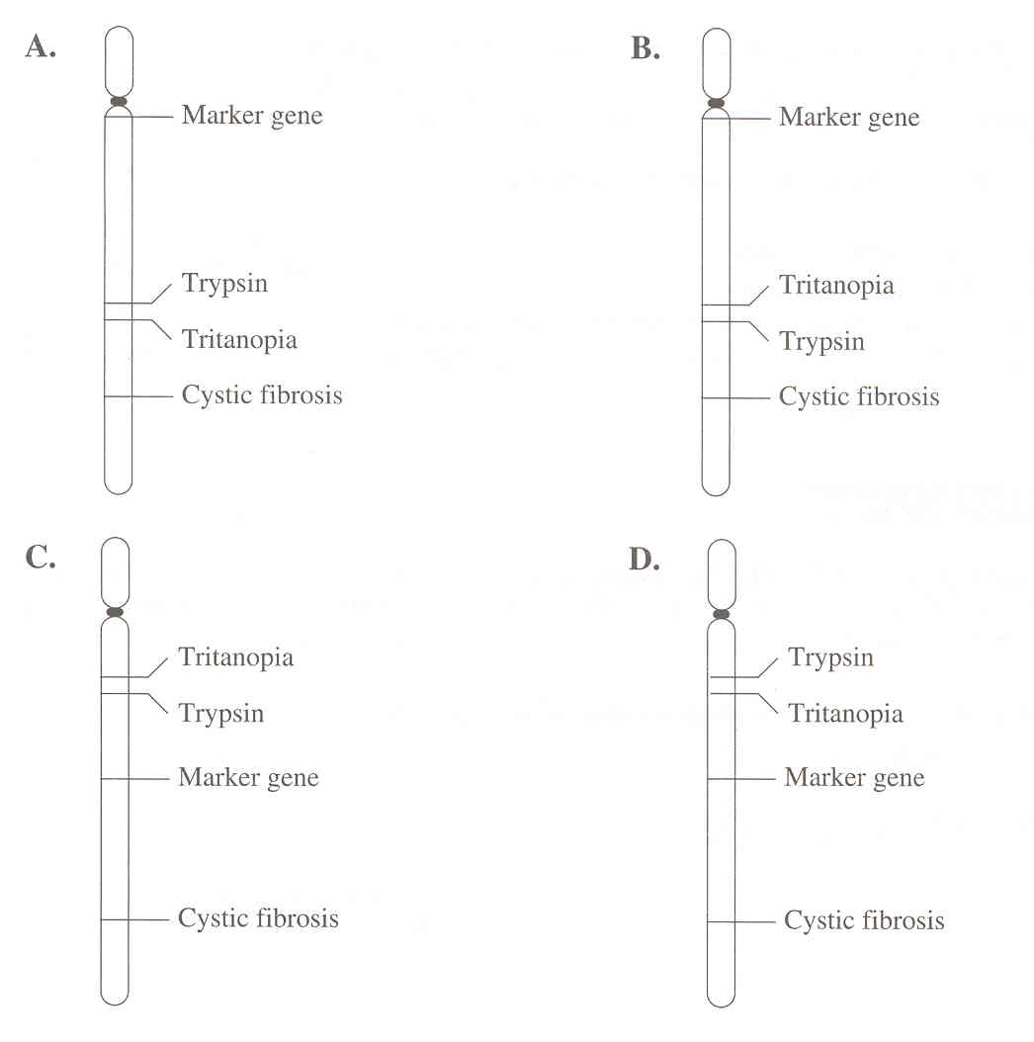

Use the following information to answer the next three questions.
Cystic fibrosis is the most common genetic disorder among Caucasians, affecting one in 2 000
Caucasian children. The cystic fibrosis allele results in the production of sticky mucus in several
structures, including the lungs and exocrine glands. Two parents who are unaffected by the
disorder can have a child with the disorder.

- Which term best describes the allele for cystic fibrosis?
  - X-linked
  - Recessive
  - Dominant
  - Codominant

Use the additional information to answer the next two questions.
A girl and both her parents are unaffected by the disease. However, her sister is affected by
cystic fibrosis.

- The genotypes of the mother and father are
  - both homozygous
  - both heterozygous
  - homozygous and heterozygous, respectively
  - heterozygous and homozygous, respectively

Numerical Response
03. These parents, who are unaffected by cystic fibrosis, are planning to have another
child. What is the percentage probability that their next child will be affected by
cystic fibrosis?

(Record your answer as a whole number percentage in the numerical-response section on the
answer sheet.)

Answer: ____25______%

Use the following information to answer the next question.
Hypophosphatemia is one of the few genetic diseases caused by a dominant allele carried on
the X chromosome. It causes a severe deficiency of phosphate ions in the blood.

—from Rimoin, et al., 1996

- A female with hypophosphatemia whose father had the disease but whose mother did not will likely transmit the disorder to
  - her sons only
  - her sons and her daughters equally
  - all of her daughters but none of her sons
  - all of her daughters and 50% of her sons

    - Certain disorders result if an extra chromosome is present in all nucleated cells of the body (trisomy) or if a chromosome is missing from all nucleated cells of the body (monosomy). These disorders arise because of nondisjunction, a malfunction that occurs during
      - DNA replication
      - RNA transcription
      - telophase of mitosis
      - anaphase of meiosis

Use the following information to answer the next question.
Portion of Insulin Protein

Phenylalanine–Valine–Asparagine–Glutamine–Histidine

- What is the strand of DNA that would code for this portion of insulin?
  - AAG CAA TTA GTT GTA
  - AAA CAA TTC CAC CTA
  - CAC GAG AAC GTA TTC
  - TTC GTA AAC GAG CAC

Use the following information to answer the next two questions.
Marfan syndrome is an autosomal-dominant disorder of humans. Affected individuals tend to
be tall and thin. They have defects in the lens of the eye and weak connective tissue around
the aorta. Often, affected individuals excel in sports like volleyball or basketball, but it is not
uncommon for people with this syndrome to die suddenly.

Numerical Response
04. A man, heterozygous for Marfan syndrome, and a homozygous recessive woman have a child. What is the probability that the child will be affected by Marfan syndrome?

(Record your answer as a value from 0 to 1, rounded to two decimal places, in the numerical-response
section on the answer sheet.)

Answer: ____0.50______

- Which of the following statements is a valid prediction about the frequency of this disorder in males and females?
  - Males are affected more often than females.
  - Females are affected more often than males.
  - Males and females are affected with equal frequency.
  - An accurate prediction cannot be made because the syndrome occurs randomly.

Use the following information to answer the next two questions.
In pea plants, tall (T) is dominant over short (t), and round seed (R) is dominant over wrinkled
seed (r). The Punnett square below shows a cross between a heterozygous tall–heterozygous
round-seed pea plant and a short–heterozygous round-seed pea plant. Different types of
offspring are represented by numbers.

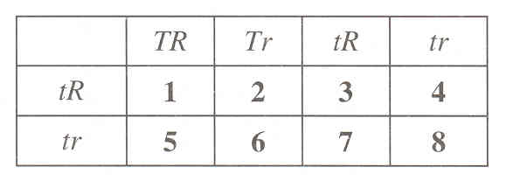

- Which two types of offspring are pure breeders for both plant height and seed shape?
  - 1 and 6
  - 2 and 5
  - 3 and 8
  - 4 and 7

- Which two types of offspring, when crossed, could be expected to produce a
population in which 50% of their offspring would be tall and 100% would produce
round seeds?
- 1 and 8
- 2 and 4
- 3 and 7
- 5 and 6

Use the following information to answer the next question.

Pedigree of Human ABO Blood Types

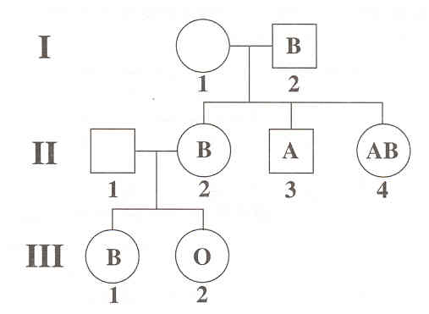

- The genotype of individual I-1 is
- ii
- IAi
- IBi
- IAIA

Use the following information to answer the next question.
In addition to the ABO system, human blood may be typed as Rh+ or Rh–. The blood types
Rh+ and Rh– are controlled by the dominant allele R (Rhesus positive) and the recessive allele
r (Rhesus negative).

Numerical Response
05. If a woman with the genotype IAIB Rr and a man with the blood type O Rh– have a
child, what is the probability that the child will have blood type A Rh–?

(Record your answer as a value from 0 to 1, rounded to two decimal places, in the numericalresponse
section on the answer sheet.)

Answer: ____0.25______

Use the following information to answer the next two questions.
A variation of leaf markings in white clover is controlled by an autosomal gene (locus). This
locus may be occupied by one of several different alleles. The allele Vh produces white lines
in long V-shapes on each leaf. The allele V1 produces white lines in short V-shapes, and the
allele v produces unlined leaves when homozygous. The order of dominance is Vh > V1 > v,
and it is assumed that dominance is complete.
A clover plant with long V-shaped lines on the leaves and a clover plant with short V-shaped
lines on the leaves produced offspring. Some of the offspring had long V-shaped lines on the
leaves, some had short V-shaped lines, and some had unlined leaves.

—from Griffiths, et al., 1993

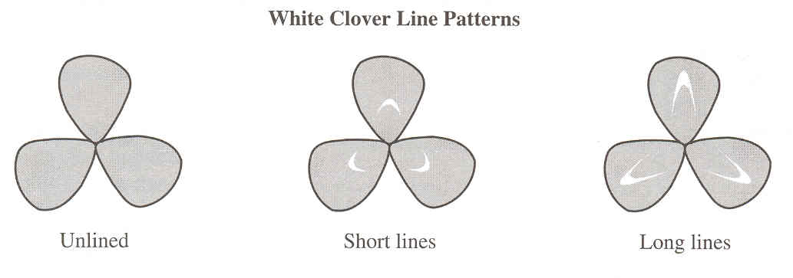

- The genotypes of the parent plant with long V-shaped lines and of the parent plant with short V-shaped lines are, respectively,
- VhV1 and vv
- Vhv and V1v
- VhV1 and V1v
- Vhv and V1V1

Numerical Response
06. What is the probability of these two parent plants producing offspring that have
unlined leaves?

(Record your answer as a number between 0 and 1, rounded to two decimal places, in the
numerical-response section on the answer sheet.)

Answer: ____0.25______

JANUARY 2000

Use the following information to answer the next four questions.
The flowering plant, Mirabilis jalapa (M. jalapa) may have branches with all white leaves, all
green leaves, and all variegated leaves (leaves with green and white patches) on the same plant.
Leaf colour is dependent on the colour of plastids present in cytoplasm. As in the case of other
plants, pollen (containing sperm nuclei) contribute chromosomes but almost no cytoplasm to the
zygote. The ovule contributes both chromosomes and cytoplasm to the zygote. The following
data of offspring phenotypes were collected from crosses between flowers from various branches.

—from Griffiths, 1993

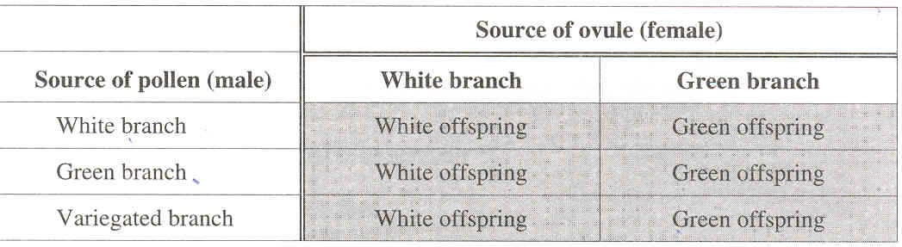

- These data indicate that, regardless of its branch source, pollen has no effect on the leaf colour of resulting offspring. A reasonable explanation for this observation is that
- leaf colour is a codominant trait
- leaf colour is a dominant–recessive trait
- cell organelles or cytoplasm are active only in pollen
- cell organelles or cytoplasm contain genetic information

Use the following additional information to answer the next question.
Several geneticists studied M. jalapa plants with deep crimson flowers and M. jalapa plants
with yellow flowers. Cross-pollinating these plants produced plants with scarlet-red flowers
(F1 generation).

These F1 plants were allowed to self-pollinate, and the resulting seeds produced M. jalapa
plants with three different flower colours. Data similar to the following were collected for
flower colour:

140 deep crimson
310 scarlet-red
160 yellow
—from Engels, 1975

- With respect to the alleles for flower colour, these results indicate
- X-linked inheritance
- gene-linked inheritance
- dominant-recessive inheritance
- incomplete dominance inheritance
Use the following additional information to answer the next two questions.
A different variety of homozygous M. jalapa produces flowers that are light crimson. Purebreeding
genotypes and phenotypes are:

RPRP – deep crimson
RR – light crimson
rr – yellow

When two pure-breeding P1 plants are cross-pollinated, only scarlet-red-flowered offspring
(RPr) are produced.

When another pair of pure-breeding P1 plants are cross-pollinated, only orange-flowered
offspring (Rr) are produced.

—from Engels, 1975

- The likely genotypes of the P1 plants for these two crosses is represented in row

Row | P1 genotypes  scarlet-red-flowered offspring | P1 genotypes  orange-flowered offspring
A. | RPR × rr | RR × rr
B. | RPRP × rr | RR × rr
C. | RPr × RPr | Rr × Rr
D. | RPRP × RR | RPR × Rr

- Which of the following phenotypes is the predicted flower colour of M. jalapa with
the genotype RPR?
- Yellow
- Orange
- Crimson
- Scarlet-red

Use the following information to answer the next two questions.
Feather colour in parakeets is controlled by two genes. For one pigment gene, the B allele
produces blue colour and the b allele does not produce any colour. For the other pigment
gene, the Y allele produces yellow colour and the y allele does not produce any colour. Any
genotype containing at least one B allele and one Y allele will produce a green parakeet

.
- Which of the following parental genotypes could produce offspring with the four different colour patterns?
- BBYy × BbYy
- BbYY × Bbyy
- bbYY × bbyy
- Bbyy × bbYy
  - What is the probability of obtaining a blue parakeet when two green heterozygous parakeets are crossed?
    - 0
    - 3/16
    - 1/4
    - 9/16

Use the following information to answer the next question.
A community of Pima Indians in the American Southwest has a very high rate of diabetes in
their adult population. Of the population of adults over the age of 35, 42% to 66% develop
diabetes. The recessive trait that causes diabetes in this population is a distinct disadvantage
to individuals whose diets are rich in carbohydrates.
—from Cummings, 1993

Numerical Response
04. If 42% of the population have diabetes, then the percentage of the population who
are carriers is calculated to be _____46_____%.

(Record your answer as a whole number in the numerical-response section on the answer sheet.)

Use the following information to answer the next two questions.
A condition called “situs inversus” causes the internal organs of an animal to be reversed and
end up on the wrong side of the body. Researchers have shown that insertion of a DNA
fragment in one particular structural gene of mice may lead to this condition. Mice
homozygous for this insertion are born with their organs reversed and die within a week of
their birth. Mice heterozygous for this insertion are born with their organs in normal positions.
—from Oliwenstein, 1993

- If two heterozygous mice were mated, what percentage of their offspring would be predicted to die?
  - 0%
  - 25%
  - 50%
  - 75%

JANUARY 2001

Use the following information to answer the next four questions.
Tay-Sachs disease is a hereditary disease that kills 1 in 360 000 individuals in the general
population, but 1 in 4 800 among the Ashkenazi (Eastern European) Jews. The disease
disrupts or halts proper formation of lysosomes and increases fat deposition around the nerve
sheath. Individuals that are homozygous for the defective allele have Tay-Sachs disease and
die at an early age. Studies suggest that heterozygous individuals have a higher survival rate
against tuberculosis than the rest of the population. Biochemical tests can be done to
determine if parents are carriers.
—from Cummings, 1994

- What type of inheritance is demonstrated in Tay-Sachs disease?
  - Autosomal recessive
  - Autosomal dominant
  - Sex-linked recessive
  - Sex-linked dominant

    - If tuberculosis regained its former role as one of the world’s deadliest diseases, then the frequency of the Tay-Sachs allele over time would
      - decrease because of a decreased selective advantage
      - increase because of an increased selective advantage
      - decrease because of an increased selective advantage
      - remain the same as a result of Hardy–Weinberg equilibrium

Numerical Response
04. A young couple decided to have genetic screening done to determine if they were
carriers of Tay-Sachs disease. If both individuals were carriers, what percentage of
their offspring would be predicted to have protection from tuberculosis but not have
Tay-Sachs disease?

Answer: ___50_______%

(Record your answer as a whole number percentage in the numerical-response section on the answer
sheet.)

Use the following additional information to answer the next question.
Genetic screening can involve producing complimentary DNA probes of a gene’s alleles and
determining if these bind to an individual’s DNA sample.

- Genetic screening results show that an individual is a carrier of Tay-Sachs if the individual’s DNA binds to
  - none of the DNA probes
  - two of the normal allele DNA probes
  - two of the defective allele DNA probes
  - one of the normal allele DNA probes and one of the defective allele DNA probes

Use the following information to answer the next two questions.
In tomato plants, purple stems (P) are dominant to green stems (p), and red tomatoes (T) are
dominant to yellow tomatoes (t). The two genes are located on separate chromosomes.

A purple-stemmed, red-tomato plant is crossed with a purple-stemmed, yellow-tomato plant.
They produce:

28 purple-stemmed, red-tomato plants
31 purple-stemmed, yellow-tomato plants
11 green-stemmed, red-tomato plants
9 green-stemmed, yellow-tomato plants

- The genetic composition of the parents is
  - PpTt and PPTT
  - PPTt and PpTT
  - PpTt and PpTt
  - PpTt and Pptt

    - One of the green-stemmed, red-tomato plants was crossed with another tomato plant. One of the offspring was a purple-stemmed, yellow-tomato plant. If this offspring were crossed with a green-stemmed, yellow-tomato plant, then the possible phenotype or phenotypes of the offspring would be
      - green-stemmed, yellow-tomato plants
      - green-stemmed, yellow-tomato plants and purple-stemmed, yellow-tomato plants
      - green-stemmed, yellow-tomato plants; purple-stemmed, yellow-tomato plants; and purple-stemmed, red-tomato plants
      - green-stemmed, yellow-tomato plants; purple-stemmed, yellow-tomato plants; purple-stemmed, red-tomato plants; and green-stemmed, red-tomato plants

Use the following information to answer the next two questions.

Gene Loci for a Tomato Plant

—from Griffiths et al., 1993

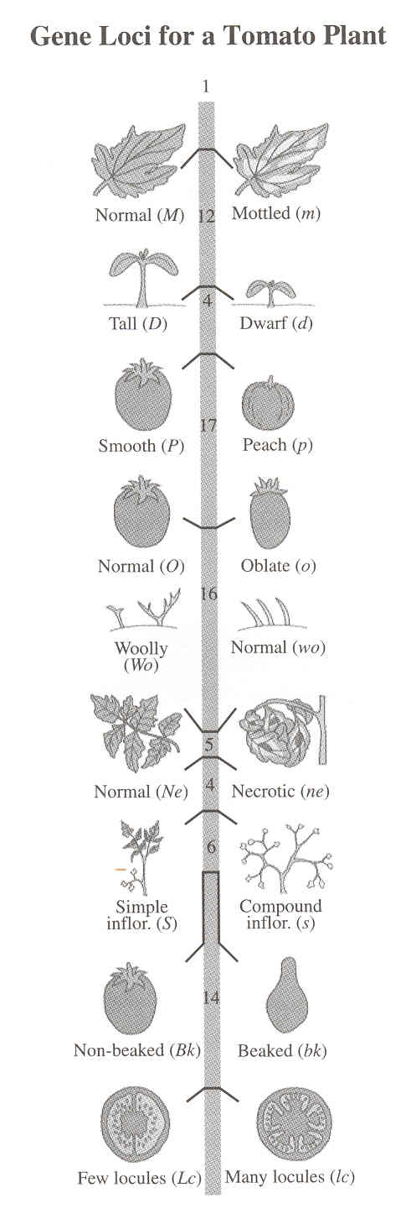

- During meiosis, which of the following pairs of genes has the greatest chance of being separated by crossing over?
  - (m) and (d)
  - (ne) and (p)
  - (m) and (lc)
  - (p) and (o)

Use the following additional information to answer the next question.
Cross-over frequencies for some genes on a tomato plant:

Genes Cross-Over Frequency
normal leaf (M) and tall plant (D) 12%
normal leaf (M) and normal tomato (O) 33%
normal leaf (M) and simple inflorescence (S) 64%
tall plant (D) and normal tomato (O) 21%
tall plant (D) and simple inflorescence (S) 52%

- The cross-over frequency between genes O and S is
  - 6%
  - 29%
  - 31%
  - 97%

Use the following information to answer the next three questions.
Punnett Square for a Dihybrid Cross to Investigate Coat Colour in Mice

Coat colour in mice is controlled by the interaction of two genes. Three phenotypes result:
black coat, brown coat, and white coat.
—from Campbell, 1993

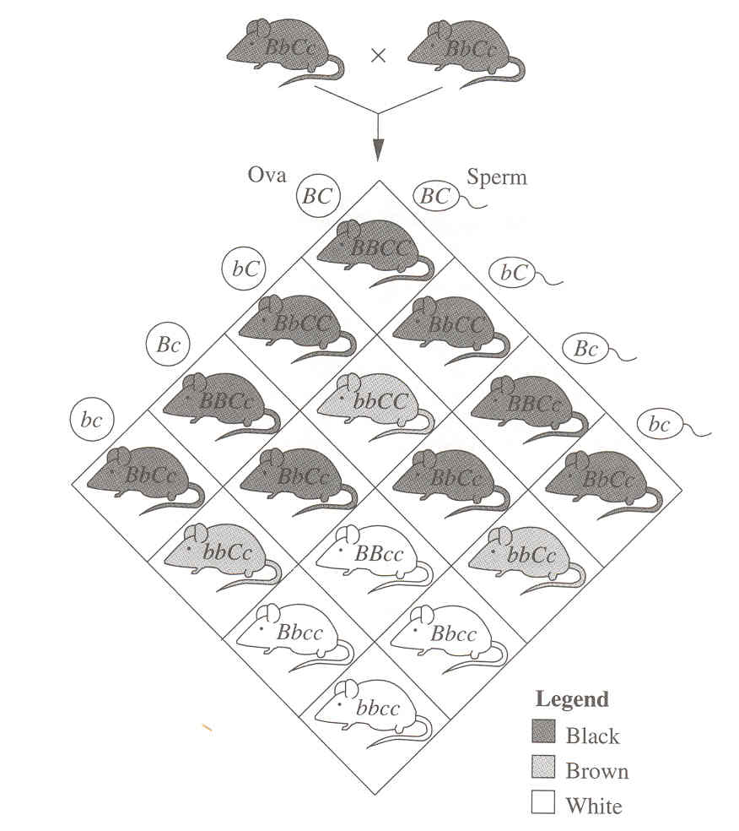

- In the dihybrid cross between the two black mice, the C allele codes for
  - black colour
  - brown colour
  - colour absent
  - colour present

Numerical Response
06. What is the expected phenotypic ratio that results from a cross between two black
mice heterozygous for both genes?

Phenotypic Ratio: ____9_____ : ____3_____ : ___4______
Coat Colour: Black Brown White

(Record your three-digit answer in the numerical-response section on the answer sheet.)

Numerical Response
07. What is the expected phenotypic ratio resulting from a cross between a bbCc female
mouse and BbCc male mouse?

Phenotypic Ratio: ____3______ : ____3______ : ____2______ OR 664
Coat Colour: Black Brown White

(Record your three-digit answer in the numerical-response section on the answer sheet.)
_______________________________________

Use the following information to answer the next question.
Farmers who raise sheep for wool try not to produce offspring with black wool. Black wool is
very brittle and difficult to dye; therefore, white wool is more desirable. If a farmer purchases
a white ram, he will generally carry out a test cross to determine whether the ram is
heterozygous or homozygous for white wool. White wool (W) is dominant to black wool (w).

- If the ram is heterozygous for white wool, the expected phenotypes of the offspring of the farmer’s test cross would be
  - all black
  - all white
  - ½ black and ½ white
  - ¾ black and ¼ white

Use the following information to answer the next three questions.
Researchers have found a gene known as p53. It codes for a protein that binds to specific
areas of DNA and activates them. This causes the production of a set of proteins that halts
cell division or, in some cells, activates the cell’s suicide program (apoptosis). The p53 gene
is activated when a cell is damaged and/or undergoes a DNA mutation.
—from Seachrist, 1996

- The normal function of the p53 gene is likely to
  - encourage a cell to undergo mitosis
  - encourage a cell to undergo meiosis
  - prevent an abnormal cell from reproducing
  - prevent the transcription of a cell suicide gene

Use the following additional information to answer the next two questions.
Research on the p53 gene was initially done with cancer cells obtained from a laboratory
animal. These cells were grown in a petri dish. A cell with two normal p53 alleles was found
to have normal cell division. Cells with one normal and one mutated p53 allele were also
found to have normal cell division. Cells that had mutations in both p53 alleles were unable
to control cell division and were associated with cancer.

- The initial research findings described above
  - demonstrate that the activated p53 gene causes cancer in lab animals
  - demonstrate that the p53 protein causes the formation of cancer cells
  - indicate that the normal p53 gene is responsible for preventing cancer in all mammals
  - indicate that the normal p53 gene is responsible for preventing cancer under laboratory conditions

    - Gene therapy that might stop uncontrolled cell division due to the mutant p53 allele would require
      - one functional p53 allele to be successfully inserted into cancer cells
      - two functional p53 alleles to be successfully inserted into cancer cells
      - one functional p53 allele to be successfully removed from cancer cells
      - two functional p53 alleles to be successfully removed from cancer cells

JANUARY 2002

Use the following information to answer the next three questions.

Tobiano Twin Colts

—Ramirez, 2000
Descriptions and Symbols Used to Represent

One Type of Coat Colour in Horses

1 2 3 4
DNA sequence for coat colour TT, Tt T Tobiano (white spotting pattern)
tt t Not tobiano (no white spotting
pattern)

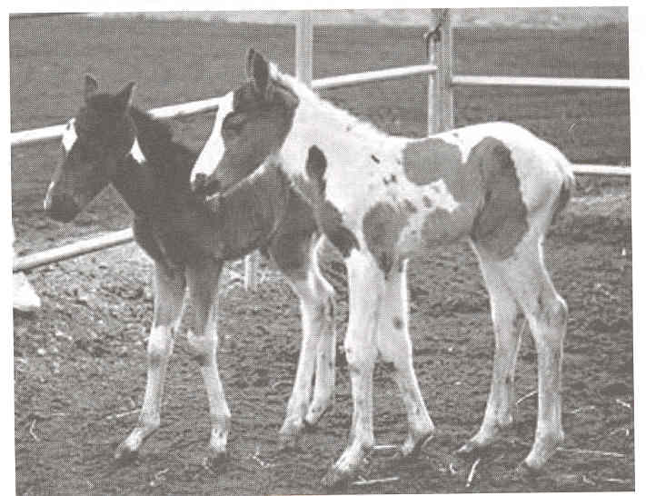

Numerical Response
05. Using the numbers above, match these descriptions and symbols with the term
below to which they apply.

Description or
Symbol Number: _____1____ _____3____ ___4______ ____2_____
Term: gene allele phenotype genotype

(Record all four digits of your answer in the numerical-response section on the answer sheet.)

- What are the genotypes for coat colour of two horses that are predicted to produce offspring in a 1:1 genotypic ratio?
  - Tt and tt
  - Tt and Tt
  - Tobiano and tobiano
  - Tobiano and not tobiano

Numerical Response
06. Given that the diploid number for horses is 64, what is the number of chromosomes
found in a horse’s somatic cell and what is the number of chromosomes found in a
horse’s gamete cell?

Number of
Chromosomes: __6__ __4__ , _3___ __2__
Cell Type: somatic cell gamete cell

(Record all four digits of your answer in the numerical-response section on the answer sheet.)

Use the following information to answer the next six questions.
Cat coat colour results from the interaction of three different genes. A gene for black-based
colours is located on an autosomal chromosome. A gene for red-based colours is located on
the X chromosome. A different gene located on a separate autosomal chromosome
determines pigment density in cat hair.

The black-based gene has three possible alleles: B–black, b–chocolate, and bl–cinnamon. If
pigmentation in cat hair is dense, the phenotypes listed below are possible.

Genotype Phenotype
BB, Bb, Bbl black
bb, bbl chocolate
blbl cinnamon

- According to the data above, the relationship among these alleles is such that the
  - black allele is codominant with the chocolate and cinnamon alleles
  - black allele is codominant with the chocolate allele, and the chocolate allele is codominant with the cinnamon allele
  - black allele is dominant over the chocolate and cinnamon alleles, and the chocolate allele is dominant over the cinnamon allele
  - black allele is dominant over the chocolate and cinnamon alleles, and the chocolate and cinnamon alleles are codominant

Use the following additional information to answer the next two questions.
There are two alleles for the pigment-density gene: dense pigment (D) and dilute pigment (d).
The chart below shows the interaction of two autosomal genes affecting coat colour—the
black-based gene and the density gene.

Black-based pigment gene | Density gene
Black-based pigment gene | D_ | dd
B_ | B_D_  black colour | B_dd  blue colour
bb; bb^{l} | bbD_; bb^{l}D_  chocolate colour | bbdd; bb^{l}dd  lilac colour
b^{l}b^{l} | b^{l}b^{l}D_  cinnamon colour | b^{l}b^{l} dd  fawn colour

- A blue-coloured female cat is bred with a cinnamon-coloured male cat. The offspring produced are black-coloured, blue-coloured, chocolate-coloured, and lilac-coloured. The genotypes of the parental cats are indicated in row

Row | Female Cat | Male Cat
A. | Bb^{l}dd | b^{l}b^{l}Dd
B. | Bb^{l}dd | b^{l}b^{l}DD
C. | Bbdd | b^{l}b^{l}Dd
D. | Bbdd | b^{l}b^{l}DD

- A black-coloured female cat with the genotype BbDd is bred with a fawn-coloured male cat. The percentage of their offspring predicted to be chocolate-coloured is
  - 13%
  - 19%
  - 25%
  - 50%

Use the following additional information to answer the next three questions.
In cats, red pigmentation is dominant to black pigmentation. The red pigment gene, which
is located on the X chromosome, has two alleles: XR and Xr. Cats with at least one XR allele
have some orange-coloured hair as a result of having the red-based pigment. Cats with only
Xr alleles have no red-based pigment. Male cats with the XR allele will be orange. However,
female cats express the genes on only one X chromosome in each cell. This expression is
random. Therefore, an orange-and-black (tortoiseshell) female cat is possible if it is XRXr.
Some genotypes and their resulting phenotypes are shown below. In all cases, pigment density
is high.

Genotype Phenotype
XRYBb Orange male cat
XrYBbl Black male cat
XRXrBb Orange-and-black female cat (tortoiseshell)

- The phenotype of a female cat with genotype XrXrBbl would be
  - a black cat
  - an orange cat
  - an orange-and-black cat
  - an orange, black, and cinnamon cat

    - A cinnamon-coloured male cat (XrYblbl) is bred with an orange-coloured female cat (XRXRBB). What possible phenotypes could be produced in the offspring?
      - Tortoiseshell-coloured female cats and orange-coloured male cats
      - Tortoiseshell-coloured female cats, black-coloured female cats, and black-coloured male cats
      - Cinnamon-coloured male cats, orange-coloured female cats, and tortoiseshell-coloured female cats
      - Cinnamon-coloured male cats, black-coloured male cats, black-coloured female cats, orange-coloured female cats, and tortoiseshell-coloured female cats

Use the following additional information to answer the next question.
When the three genes that code for black-based colour, red-based colour, and density
combine, they produce other coat colours in cats.

- What is the predicted phenotype of a female cat with genotype XRXRBbldd?
  - Black
  - Orange
  - Cinnamon
  - Cream (light orange)

Use the following information to answer the next six questions.
Sickle cell anemia is an autosomal recessive genetic disorder. Because individuals affected by
sickle cell anemia have defective hemoglobin proteins, their blood cannot transport oxygen
properly. There appears to be a relationship between the incidence of malaria and sickle cell
anemia. Individuals with sickle cell anemia and carriers of the sickle cell allele have some
resistance to malaria. Malaria is caused by the parasite Plasmodium and is transmitted
between humans by mosquitoes.

- The probability of two carrier parents having a child with sickle cell anemia is
- 25%
- 50%
- 75%
- 100%

  - If scientists are successful in significantly reducing or eliminating malaria, the best prediction for what will happen to the allele for sickle cell anemia in the population is that it will
- not be affected by the elimination of malaria
- increase as its selective advantage is increased
- be reduced as its selective advantage is decreased
- quickly disappear as its selective advantage is increased

