A Few Concepts **(NOT ALL)**

To Review For Biology 30

Chapter to know from your text book:

Chapter 13

Chapter 14

Chapter 15

Chapter 16

Chapter 17

Chapter 18

Chapter 19

Chapter 20

Chapter 21

Chapter 22

Chapter 23

1. Complete the table below

|  |  |  |
| --- | --- | --- |
| **Endocrine gland** | **Hormone secreted** | **Effects of hormone on target tissues/organs** |
| hypothalamus | Releasing Hormones | regulates anterior pituitary hormones |
| anterior pituitary |  | stimulates cell division, bone and muscle growth, and metabolic functions |
|  | stimulates the thyroid gland |
|  | stimulates the adrenal cortex to secrete glucocorticoids |
|  | stimulates production of ova and sperm from the ovaries and testes |
|  | stimulates sex hormone production from the ovaries and testes |
|  | stimulates milk production from the mammary glands |
| posterior pituitary |  | promotes the retention of water by the kidneys |
|  | stimulates uterine muscle contractions and release of milk by the mammary glands |
| thyroid |  | affects all tissues  increases metabolic rate and regulates growth and development |
|  | targets bones and kidneys to lower blood calcium from bone and reabsorption of calcium by kidneys |
| parathyroid |  | raises blood calcium levels by stimulating the bone cells to release calcium, the intestine to absorb calcium from food, and the kidneys to reabsorb calcium |
| adrenal cortex |  | stimulate tissues to raise blood glucose and break down protein |
|  | promote reabsorption of sodium and water by the kidneys |
|  | promote secondary sexual characteristics |
| adrenal medulla |  | fight-or-flight hormones  raise blood glucose levels |
| pancreas |  | lowers blood glucose levels and promotes the formation of glycogen in the liver |
|  | raises blood glucose levels |
| ovaries |  | stimulates uterine lining growth and promotes development of the female secondary sexual characteristics |
|  | promotes growth of the uterine lining and prevents uterine muscle contractions |
| testes |  | promotes sperm formation and development of the male secondary sexual characteristics |

1. 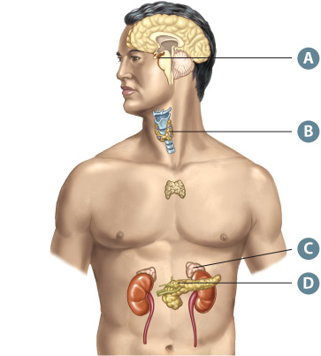Complete the table below.

|  |  |  |  |  |
| --- | --- | --- | --- | --- |
| Letter on Diagram | Name of Hormonal Imbalance | Endocrine Gland or Glands Involved | Hormones Involved | Symptoms of the Condition |
|  | Diabetes Mellitus |  |  |  |
|  | Diabetes Insipidus |  |  |  |
|  | Acromegaly |  |  |  |
|  | Hyperthyroidism |  |  |  |
|  | Hypothyroidism |  |  |  |
|  | Addison’s Disease |  |  |  |
|  | Goitre |  |  |  |

1. 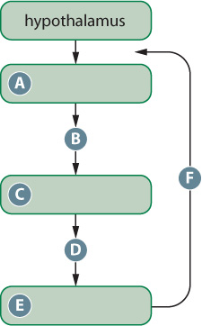On the flow chart identify the following.
   1. Hormone released from the pituitary gland.
   2. Endocrine gland affected.
   3. Hormone released from the endocrine gland.
   4. Effects on the body systems and tissues.
   5. What regulates the hormone.

Other Endocrine Feedback Loops:

1. Annotate the diagram below, in your annotations include

* the structure and types of neurons indicated by the letter in the diagram.
* the functions of these structures and neurons.
* the direction of the neuron transmission.

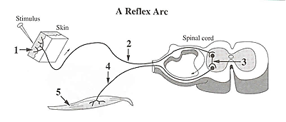

Label and annotate the diagram of the brain below.



1. Label and annotate the diagrams below

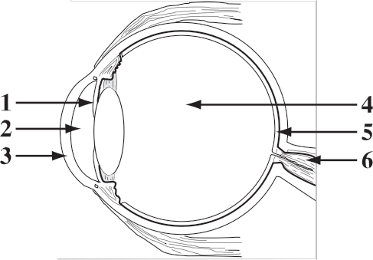

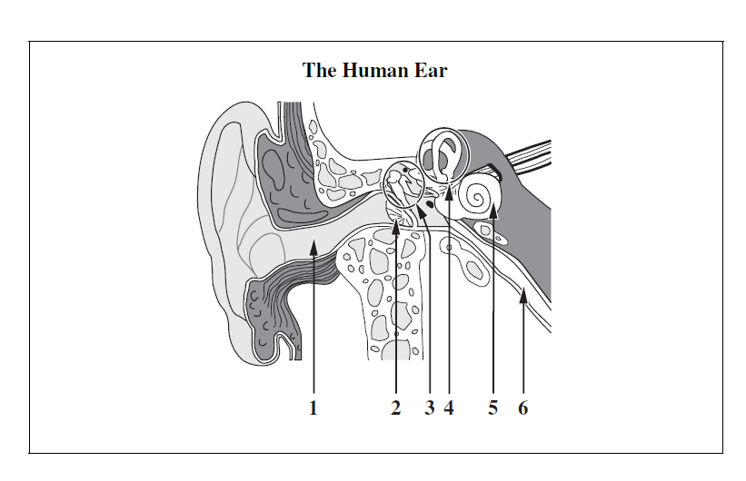

1. Annotate the following diagrams.

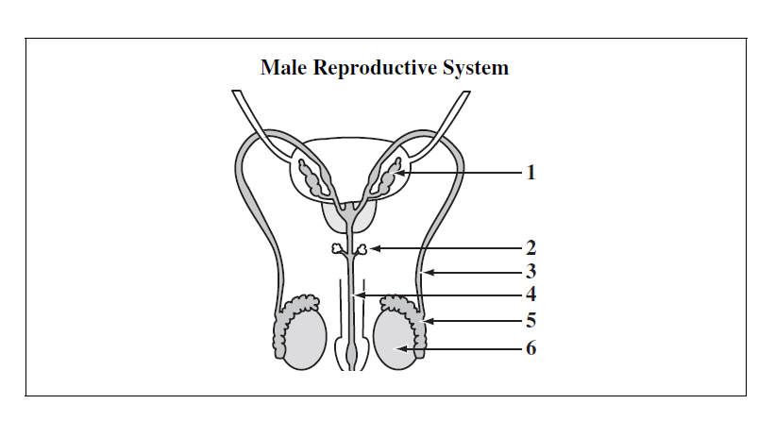

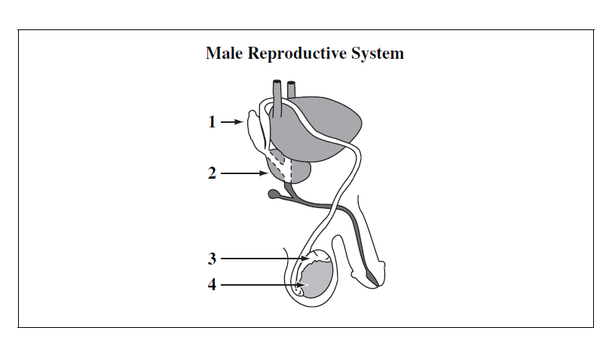

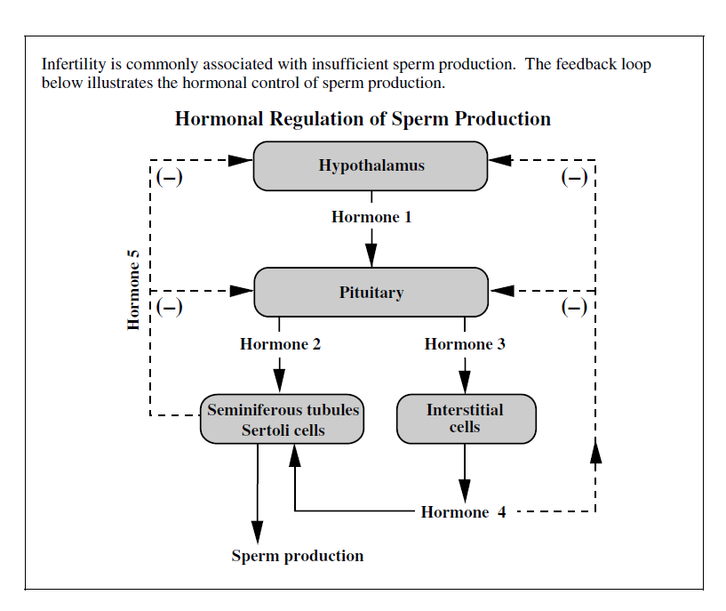

1. Annotate the following diagram.

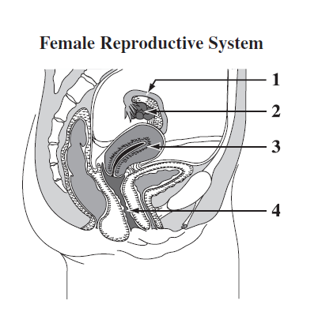

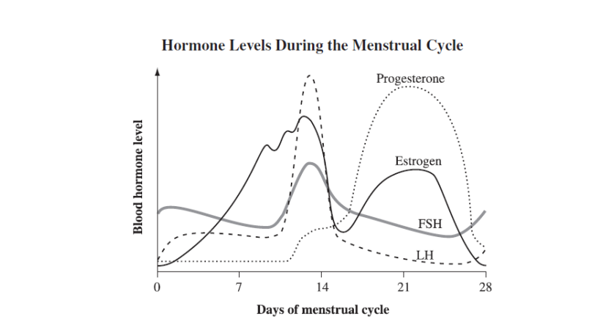

1. 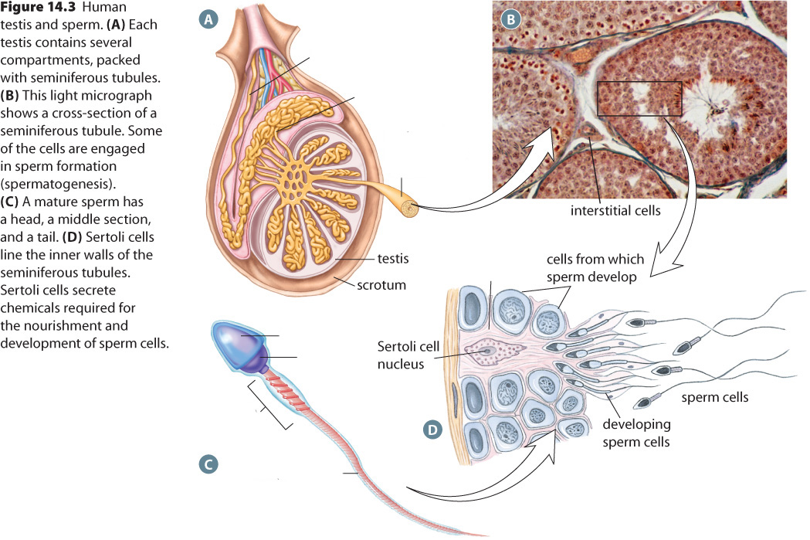Annotate the following diagrams

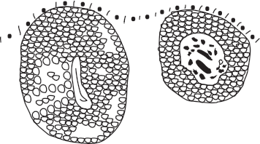

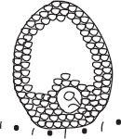

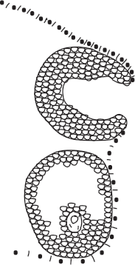

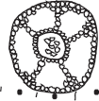

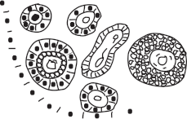



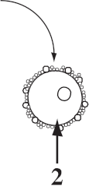

**A Human Ovary**

1. Annotate the following diagram.

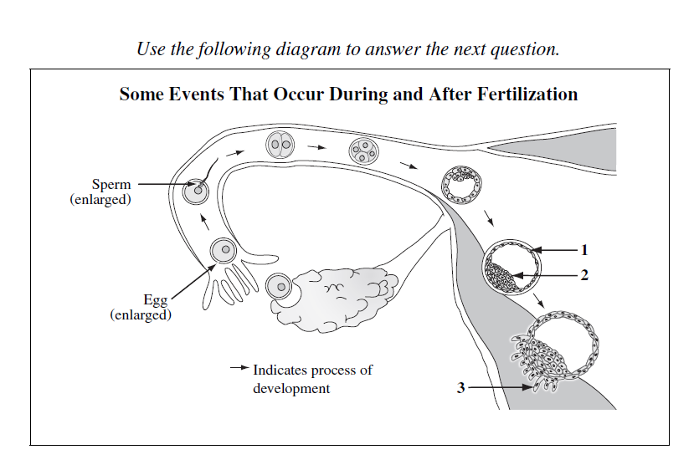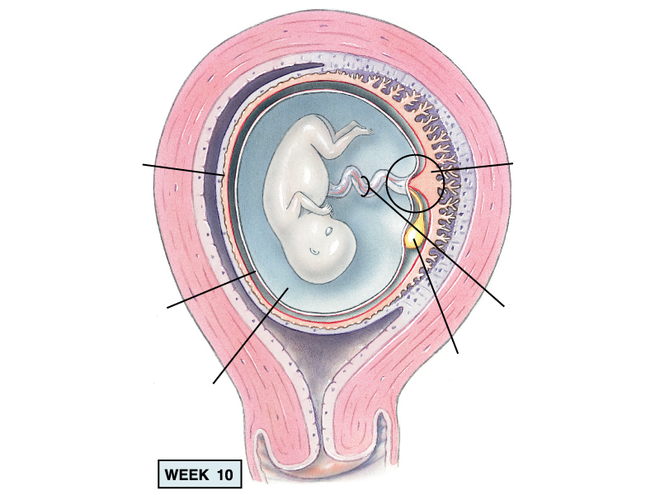

1. Compare and contrast the two processed below.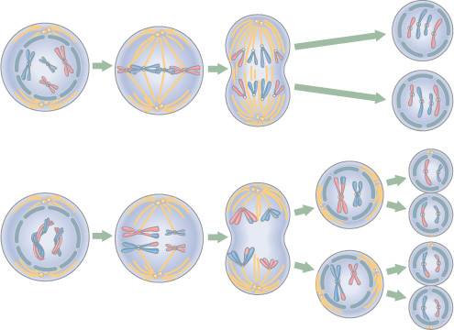Annotate the diagram below

Adult butterflies are diploid. The sex chromosomes in adult female butterflies are W and Z chromosomes, whereas the sex chromosomes in adult male butterflies are two Z chromosomes.

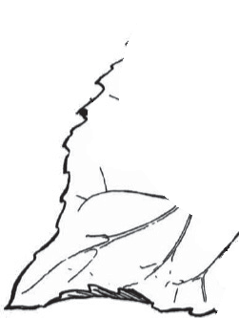

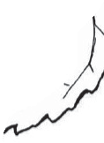





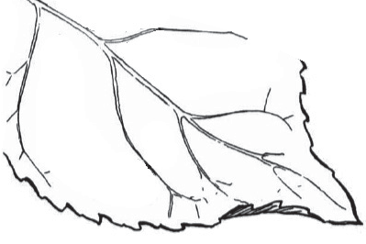





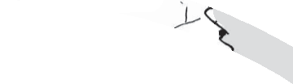



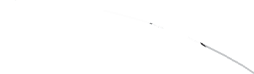

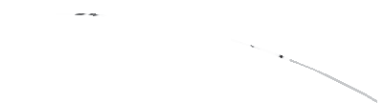

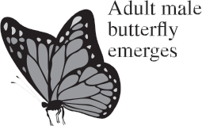

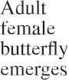





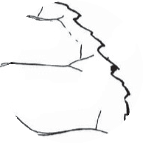































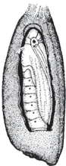



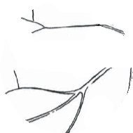



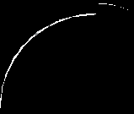

































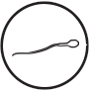















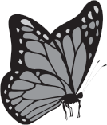

**Life Cycle of a Butterfly**

**29.** A karyotype of Structure 1 in the diagram above would have

**A.** two copies of each autosome and two Z chromosomes

**B.** one copy of each autosome and either a W or a Z chromosome

**C.** one copy of each autosome, a W chromosome, and a Z chromosome

**D.** two copies of each autosome, a W chromosome, and a Z chromosome

1. Annotate and complete the flowchart.

**TACCGTTTAACGAGAAAAAAGAATGACCCCAAAATT**

Another mutation in the connexin 26 gene involves the deletion of two bases and their replacement by two new bases. The deletion is shown below.

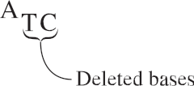

The two deleted bases are replaced by two adenine bases.

—based on *Human Gene Mutation Database*, 2010

Institute of Medical Genetics. 2010. Gene symbol: *GJB2*. *Human Gene Mutation Database.* Cardiff University. [www.hgmd.cf.ac.uk/ac/index.php.](http://www.hgmd.cf.ac.uk/ac/index.php)

**39.** The transcription of the mutated connexin 26 gene described above results in the replacement of a

**A.** stop codon with a lysine codon

**B.** methionine codon with a lysine codon

**C.** stop codon with a phenylalanine codon

**D.** methionine codon with a phenylalanine codon

1. Define the following enzymes:
   1. Ligase
   2. Restriction Endonuclease
   3. DNA Polymerase
   4. Polymerase Chain Reaction (PCR)
   5. DNA electrophoresis
2. State the genotypes of each individual

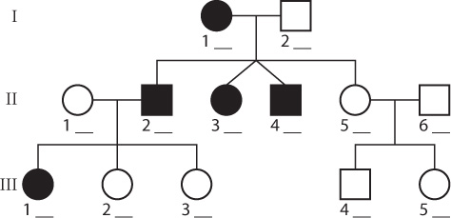

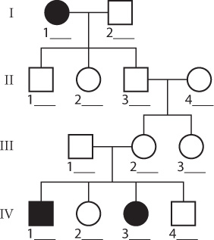

1. A population of rattlesnakes contains 1000 individuals. During the year, there are 106 births, 53 deaths, 42 immigrations, and 15 emigrations. Calculate the per capita growth rate for the year.
2. About 40 people out of 360 have the recessive lactose intolerance in Canada. Calculate the genotypic and phenotypic frequencies in the Canadian population.